**Detailed Documentation Sheikh Muhammed Tadeeb**

**Step1)**

For testing my codes, I will install Oracle Virtual Box (Type-2 Hypervisor) on my windows machine:

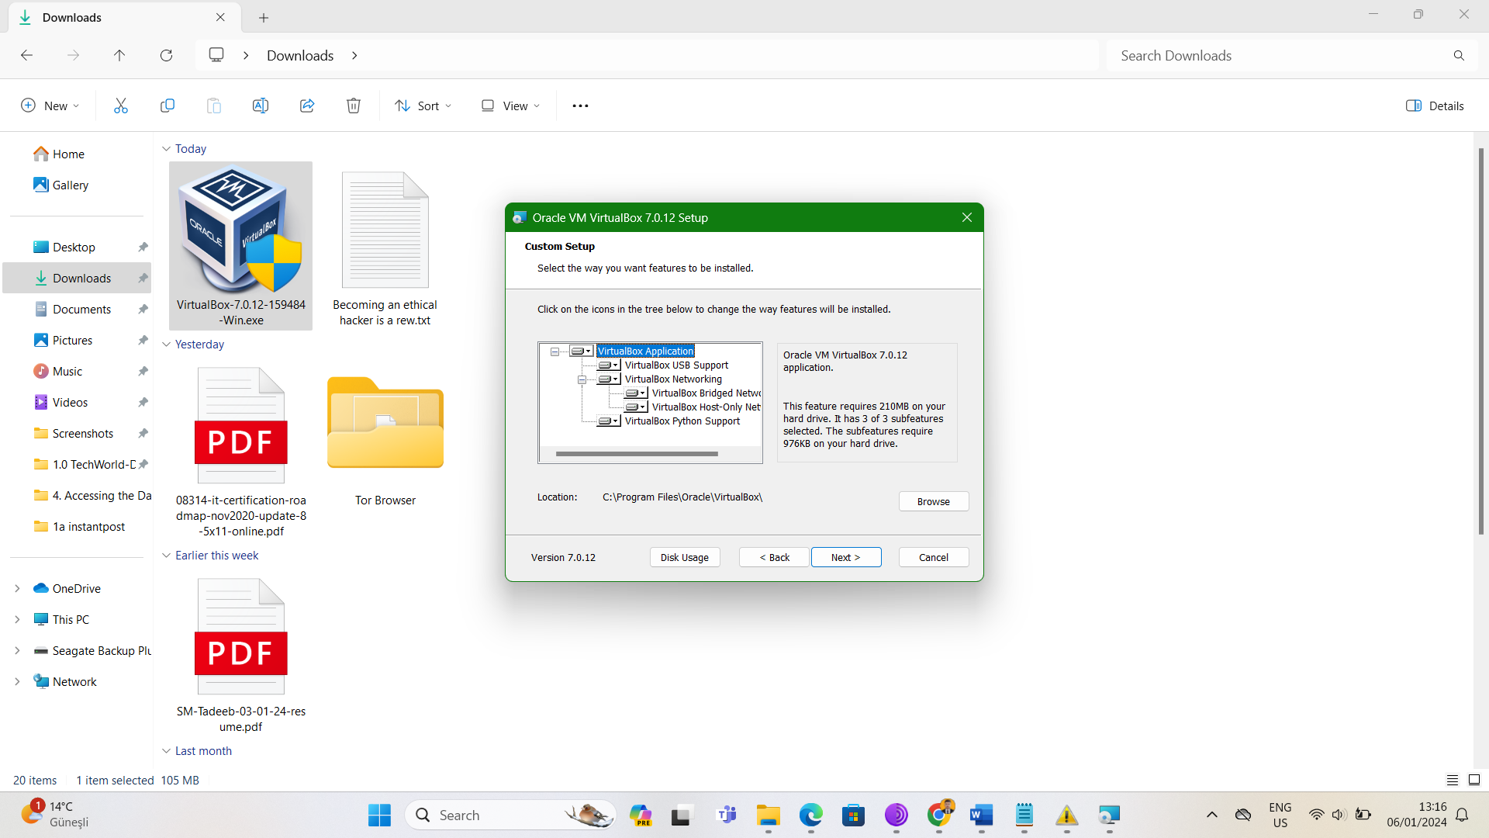

**Step2)** Inside this Oracle VirtualBox I will launch:

* Vm-1 (Salt Master)
* Vm-2 (Minion-1 with Ubuntu as OS)
* Vm-3 (Minion-3 with CentOS as OS)

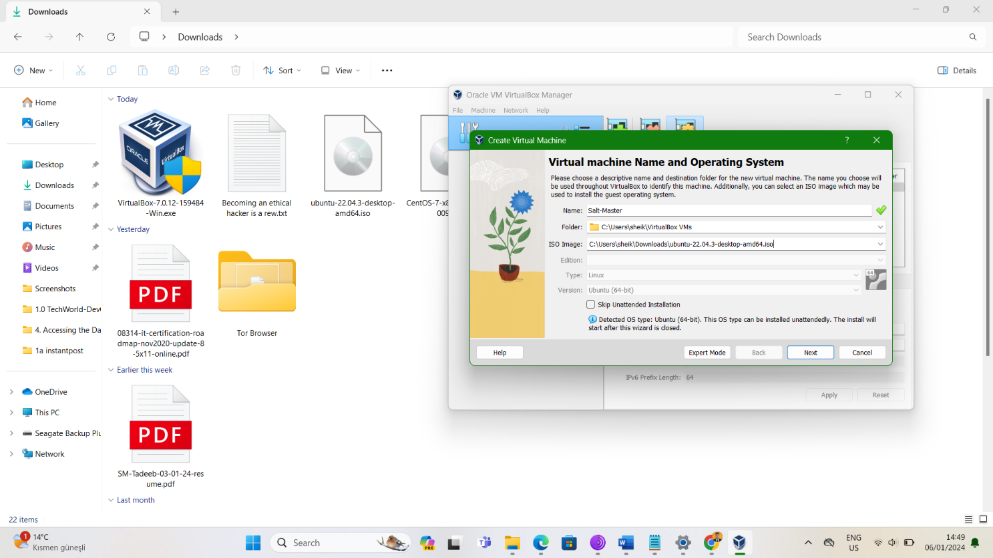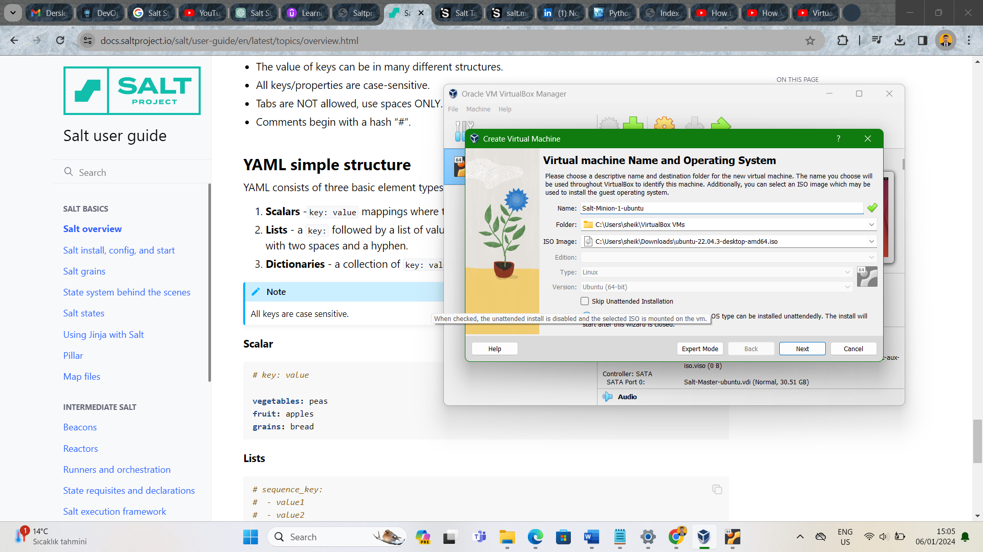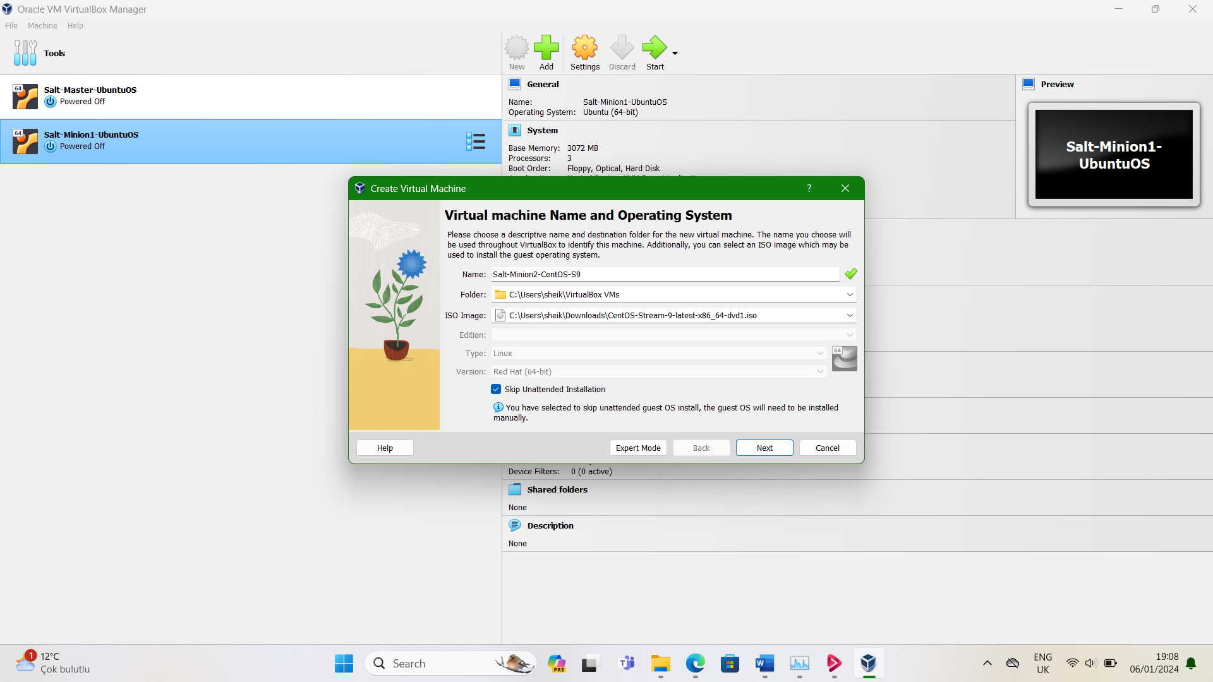



**Step3)** All these machines will be **NAT network**:

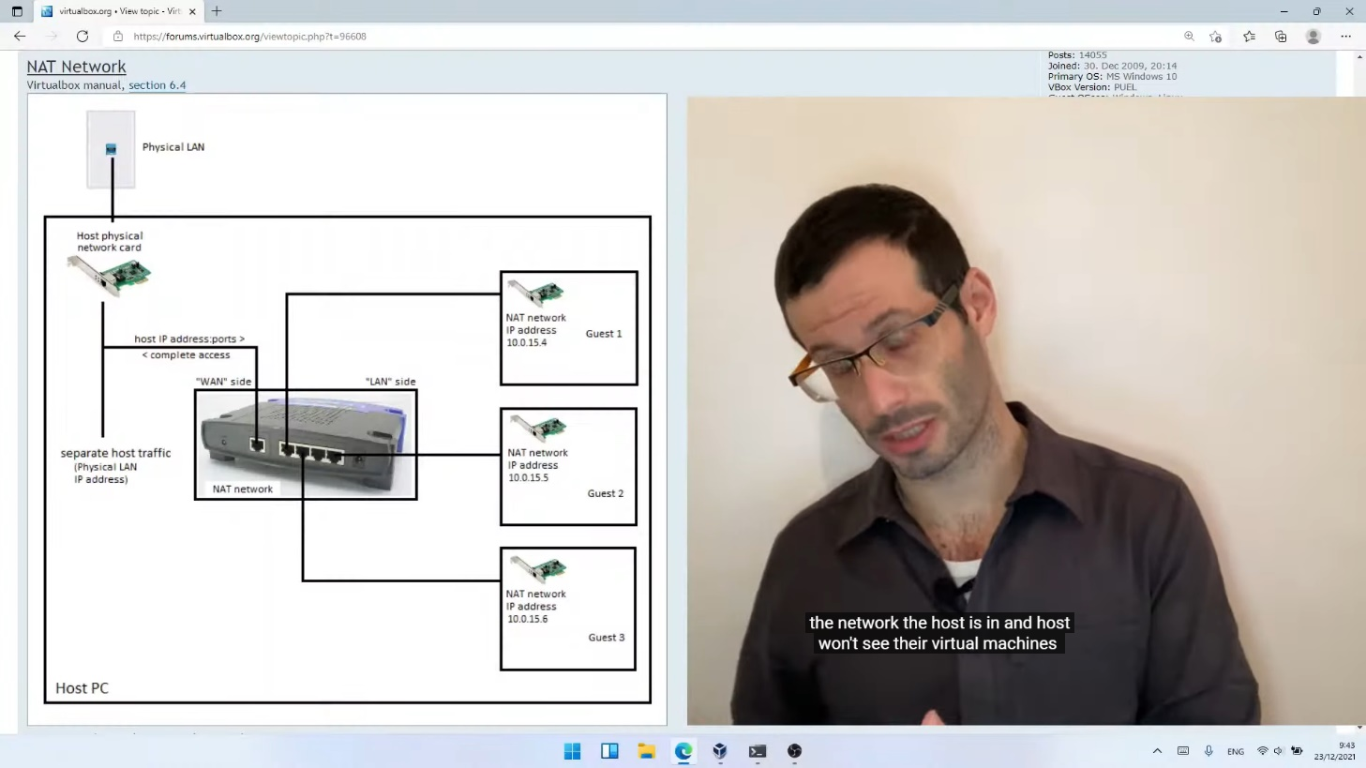

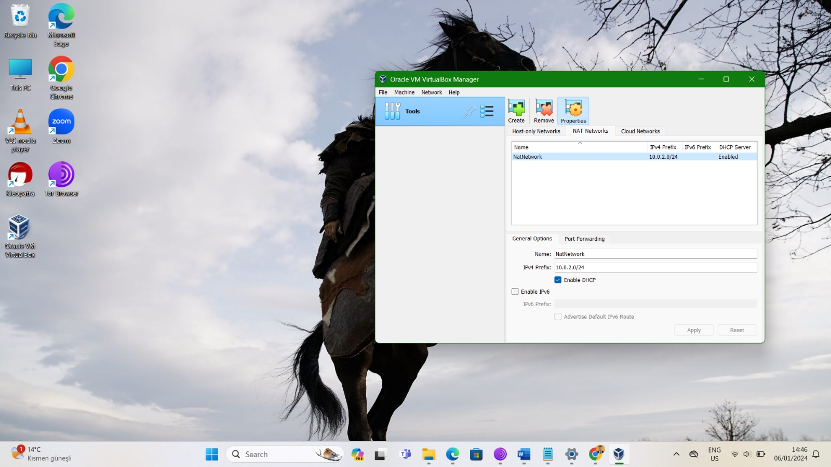

We can see machines are in same LAN.

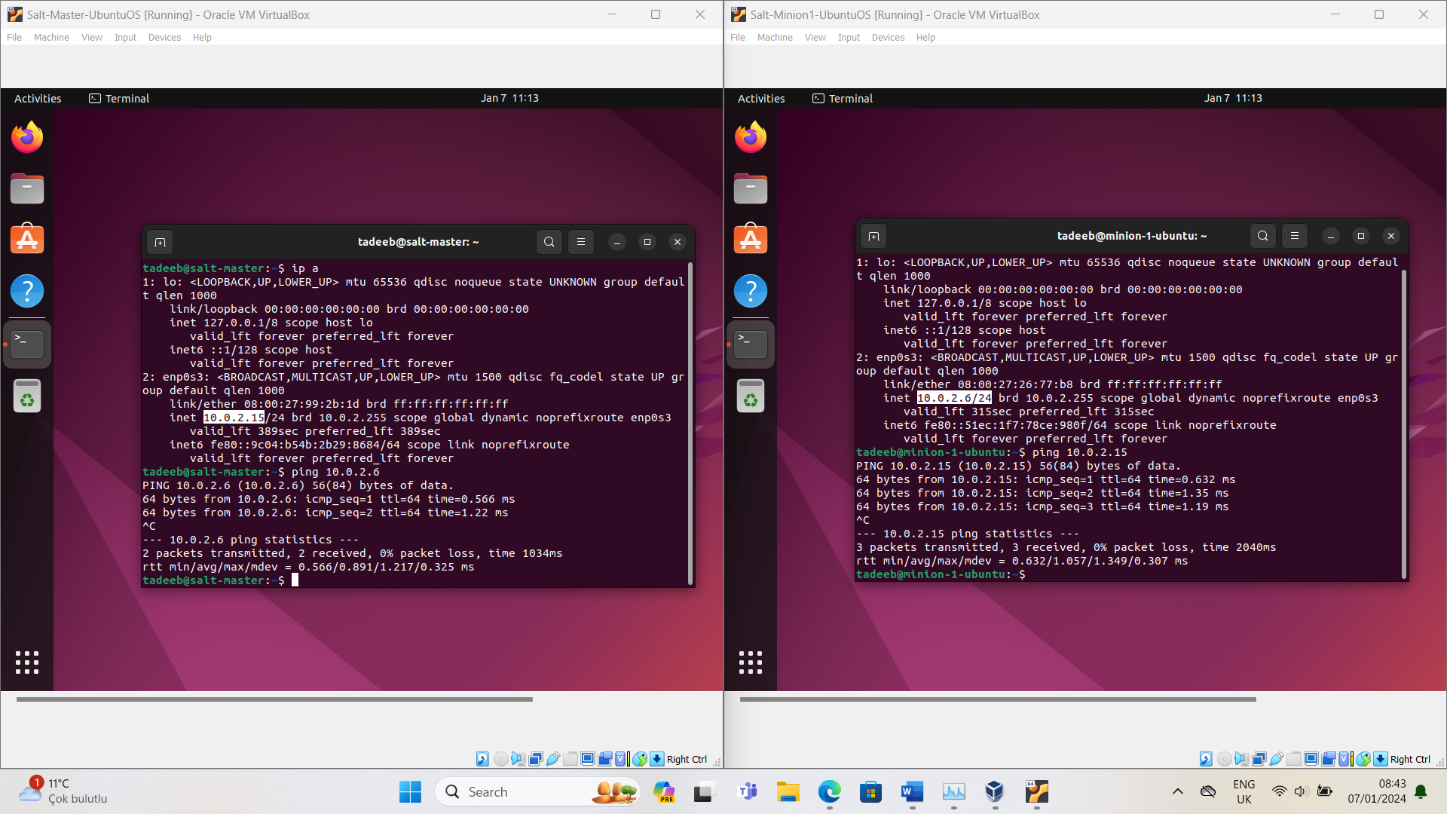

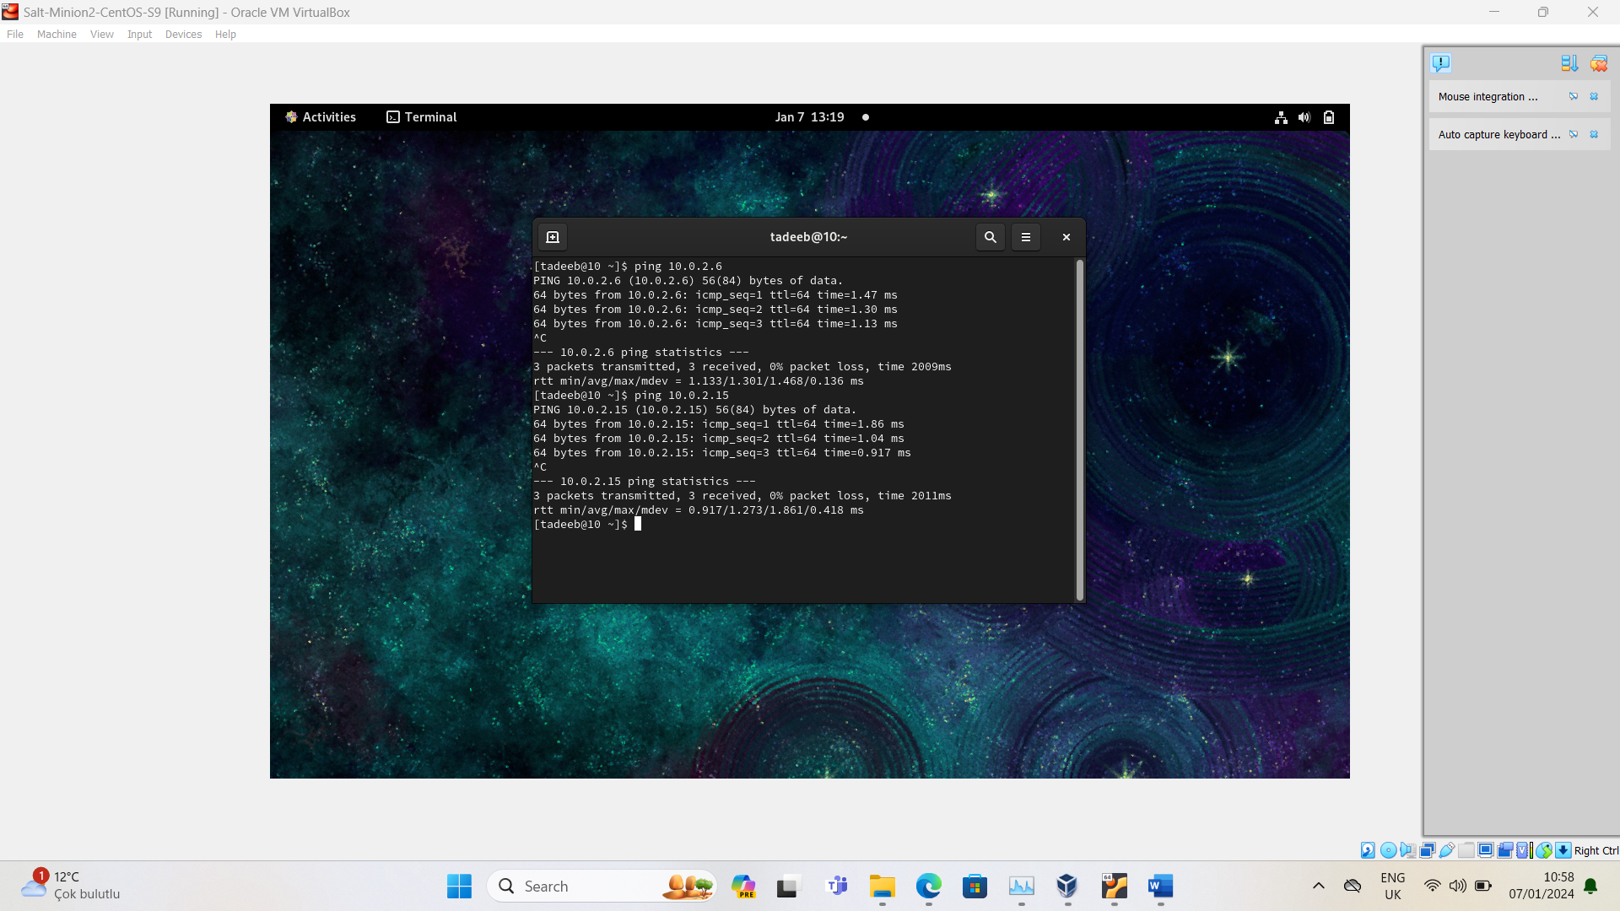

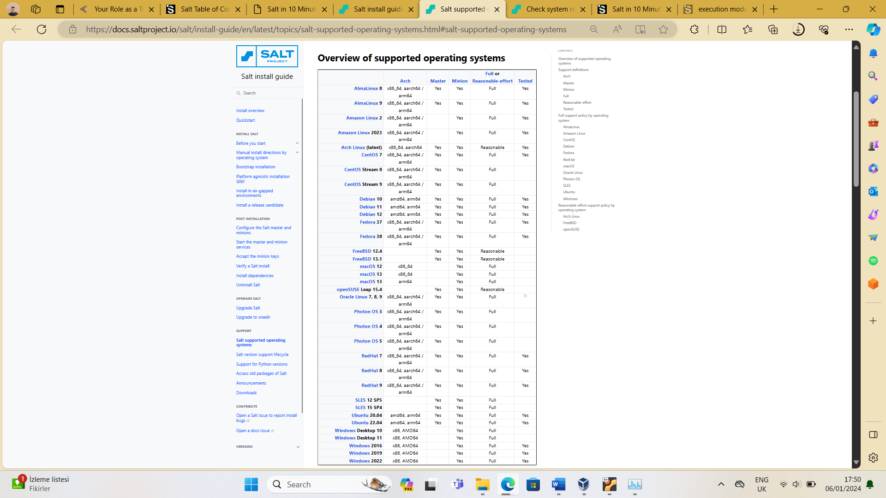**Step4) Before installing Salt. I just checked pre-requisites.**

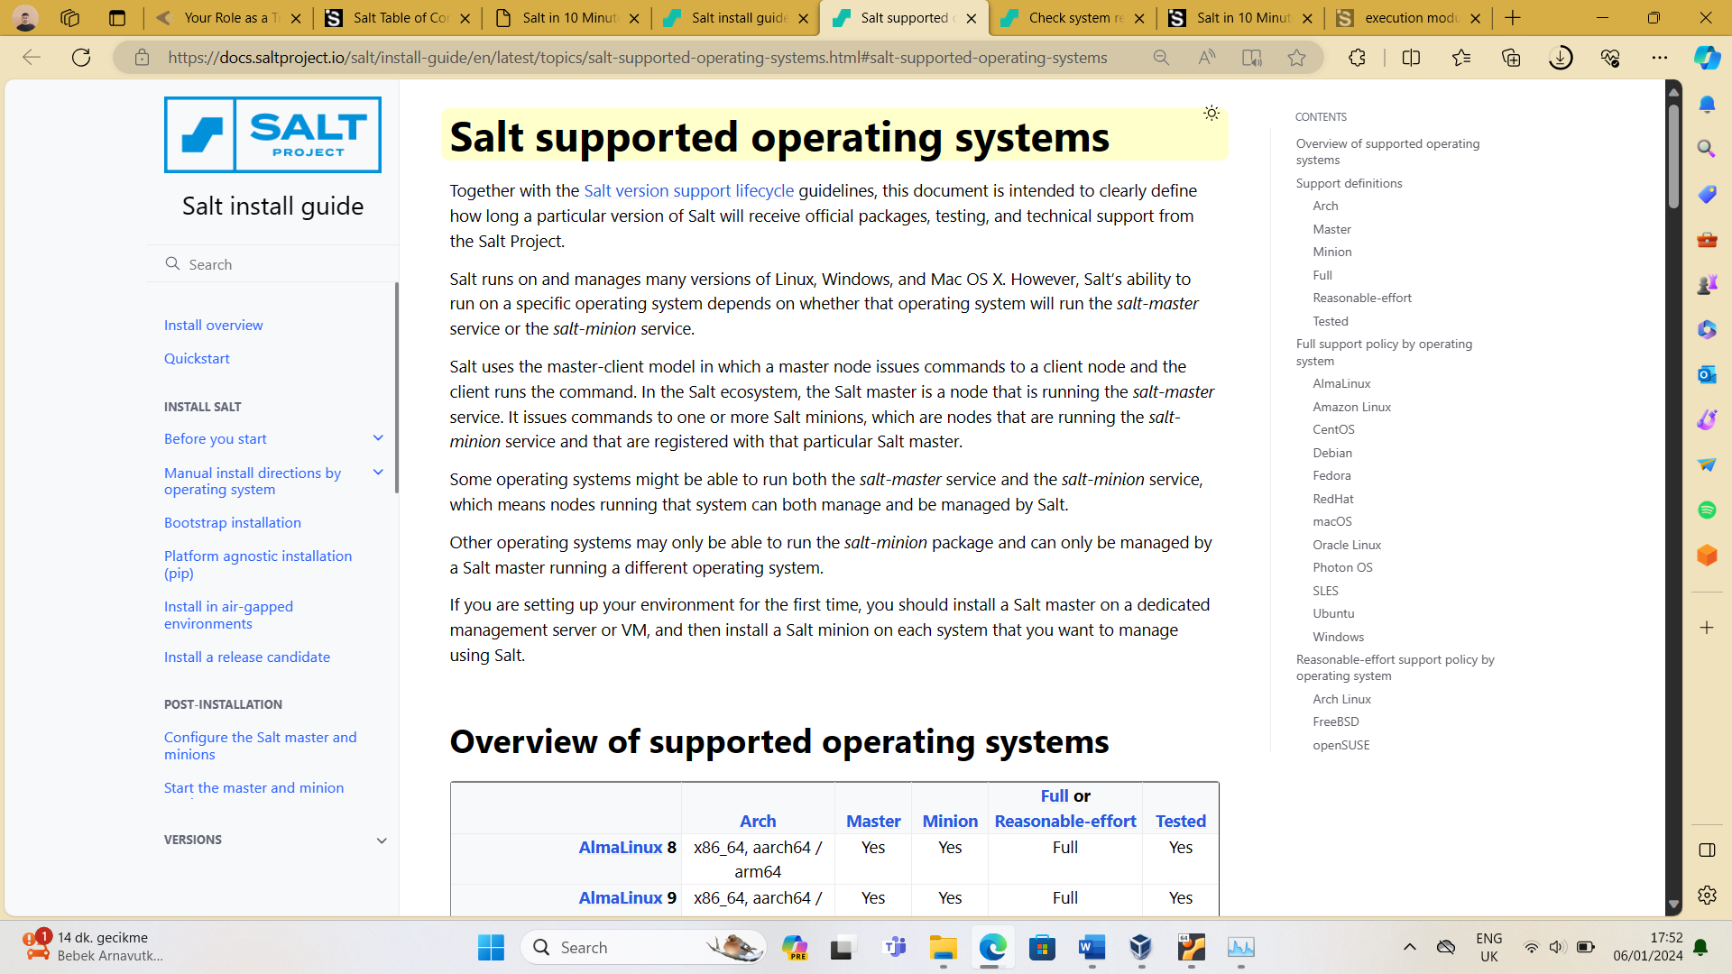

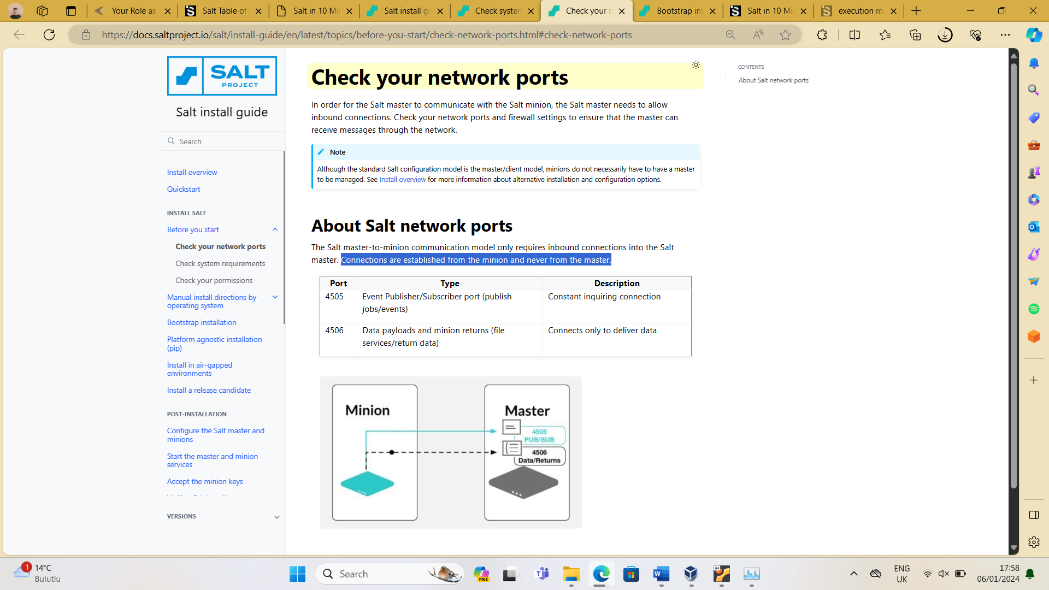

**Step5) Install Salt on Master and minions:**

I used these 2 links below from official Salt website only:

[Salt install guide (saltproject.io)](https://docs.saltproject.io/salt/install-guide/en/latest/)

[Bootstrap installation - Salt install guide (saltproject.io)](https://docs.saltproject.io/salt/install-guide/en/latest/topics/bootstrap.html#install-bootstrap)

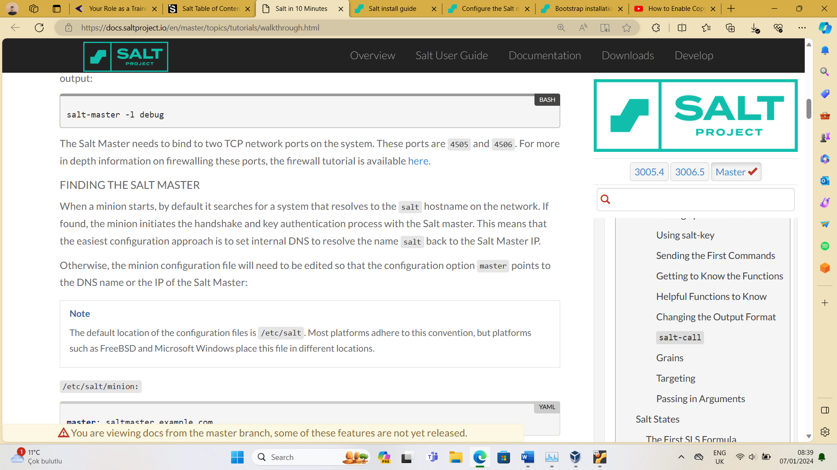**Step6) Just start Master and minion services and do necessary changes in minion machines /etc/hosts file so that they can find Master.**

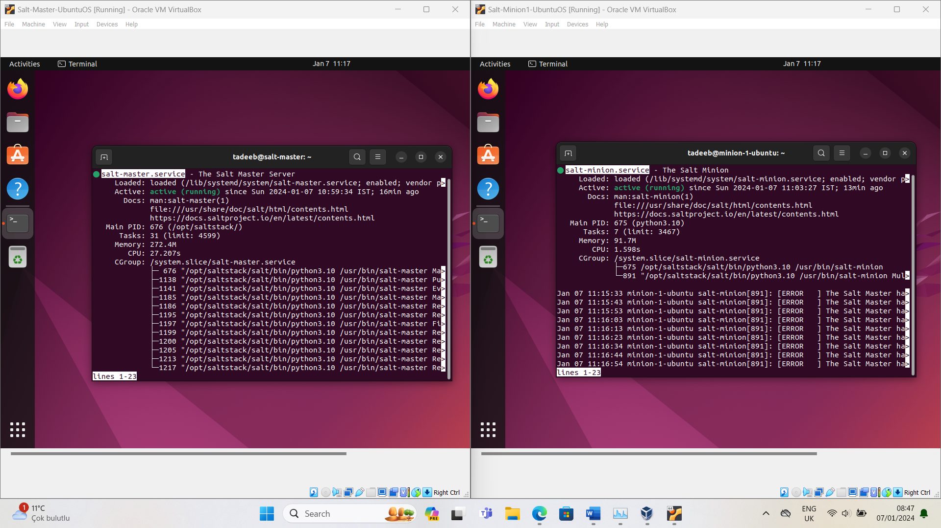

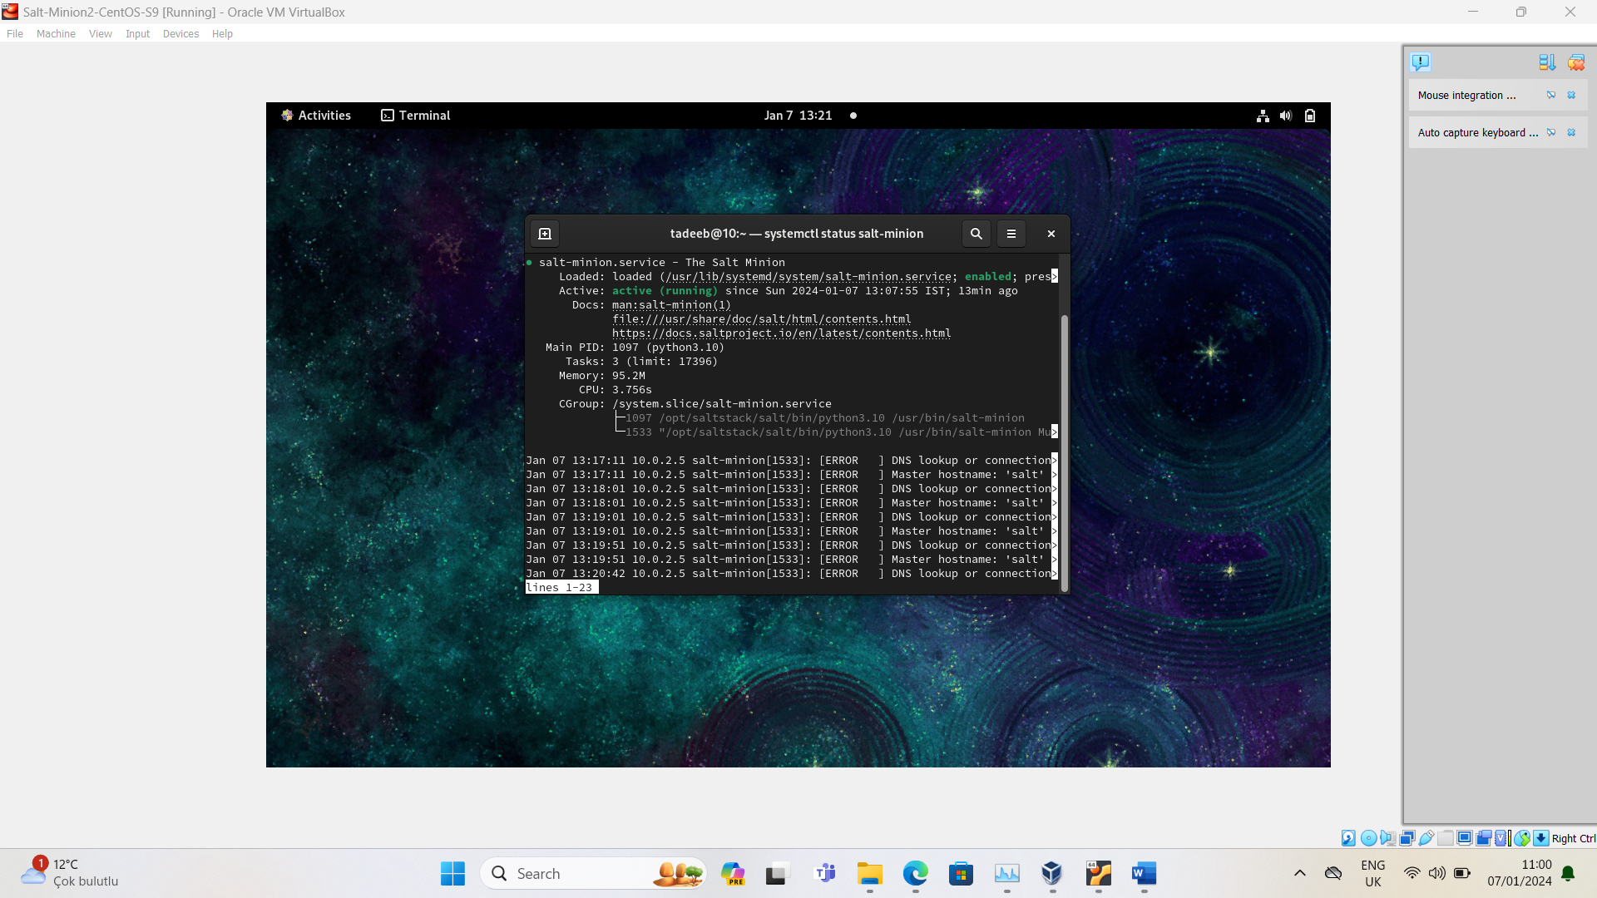

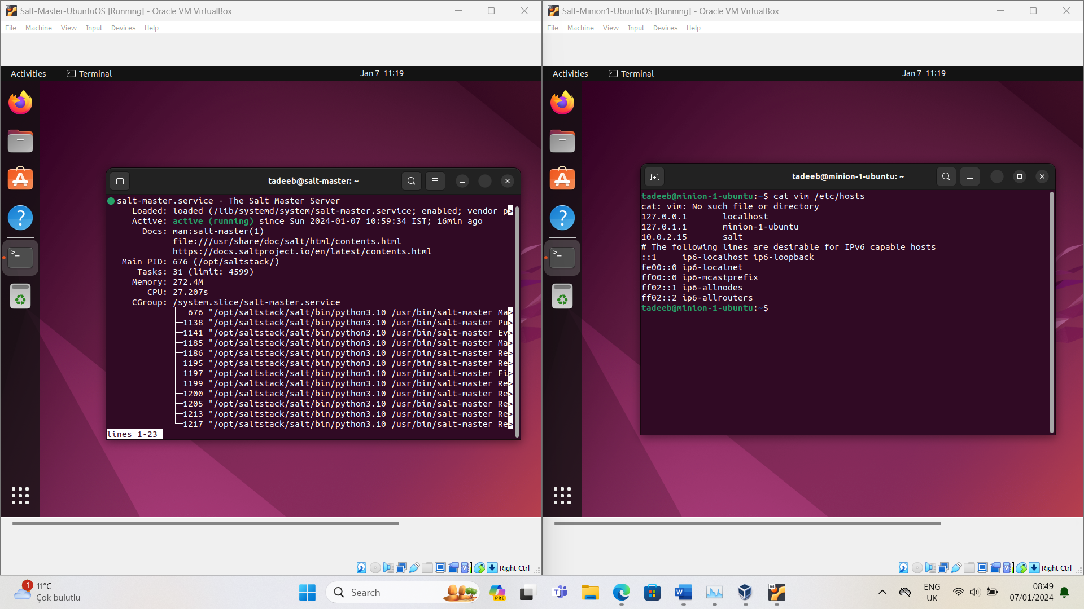

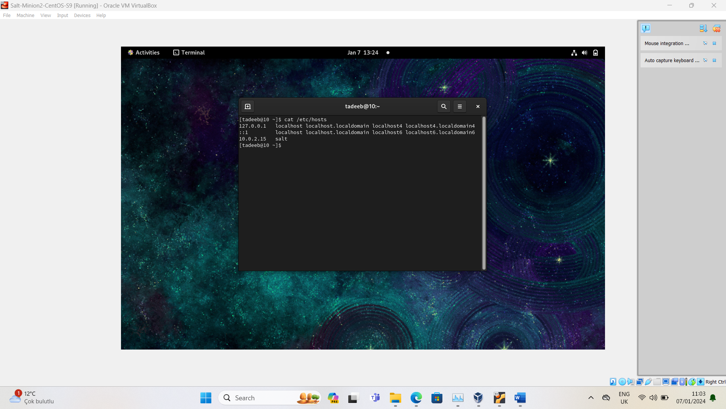

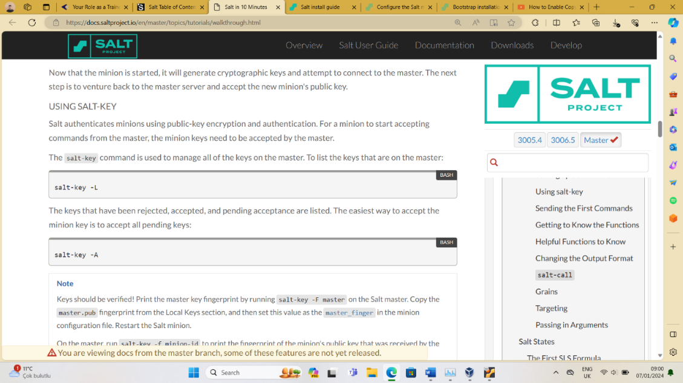**Step7) Accepting Minions keys from master**

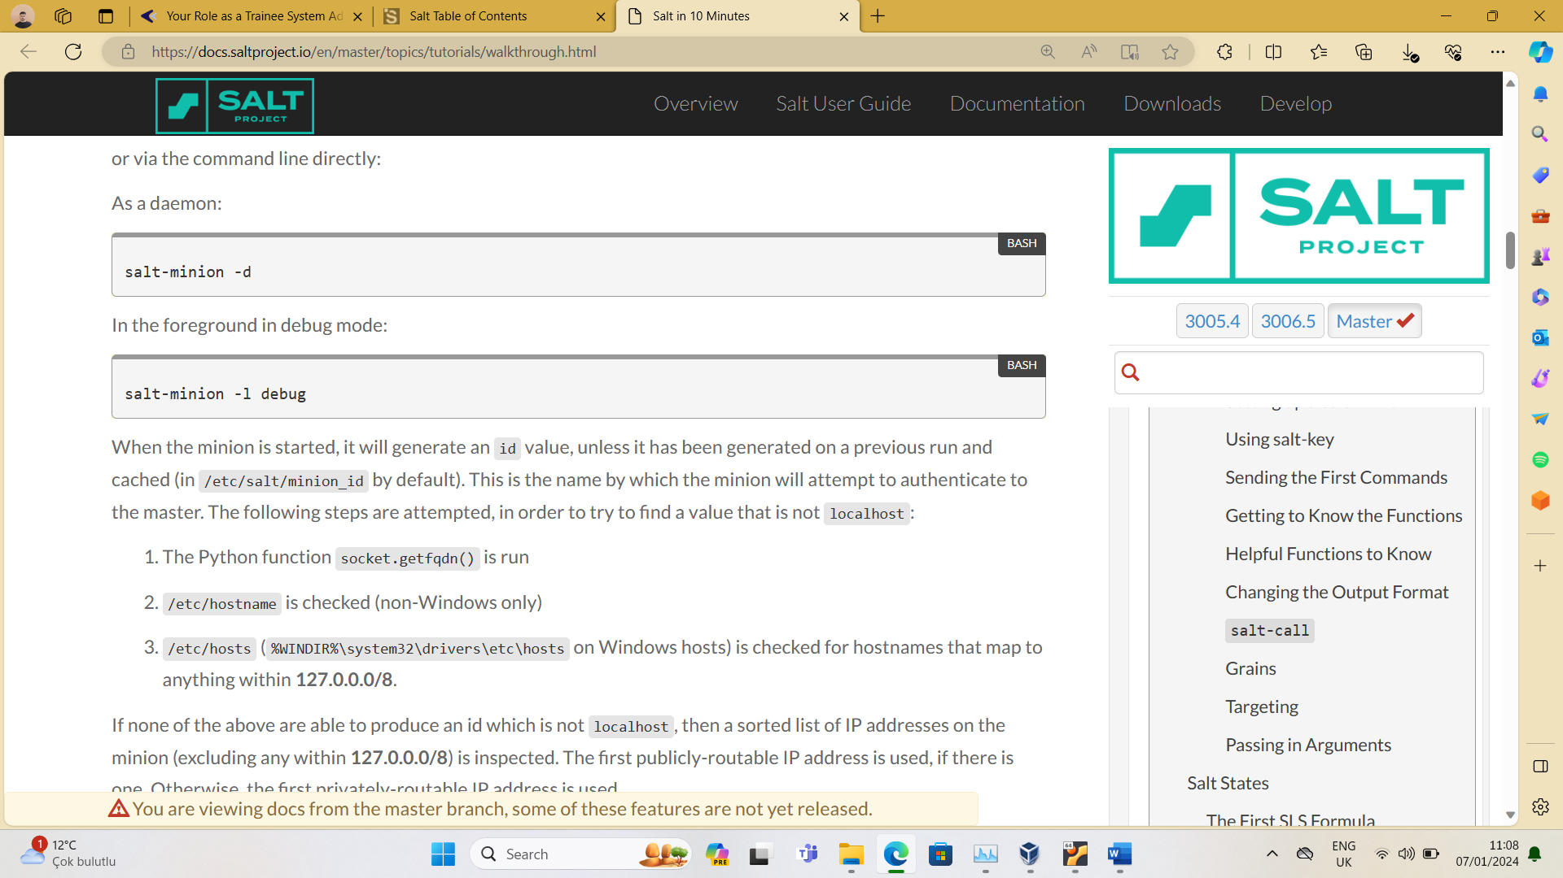

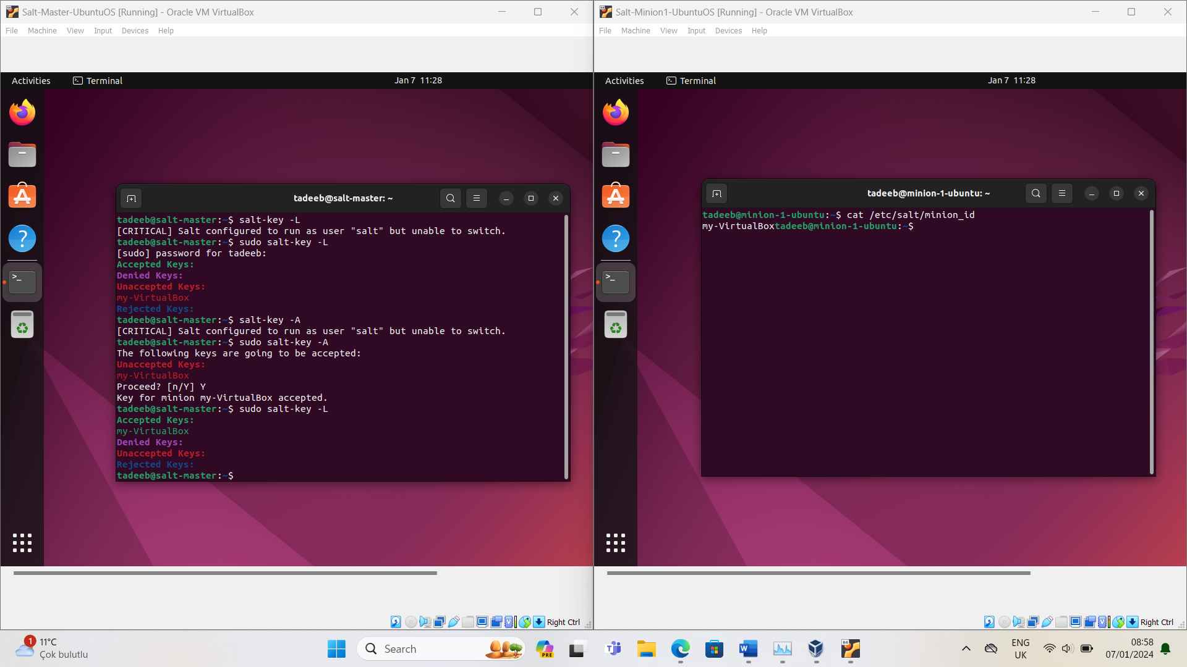



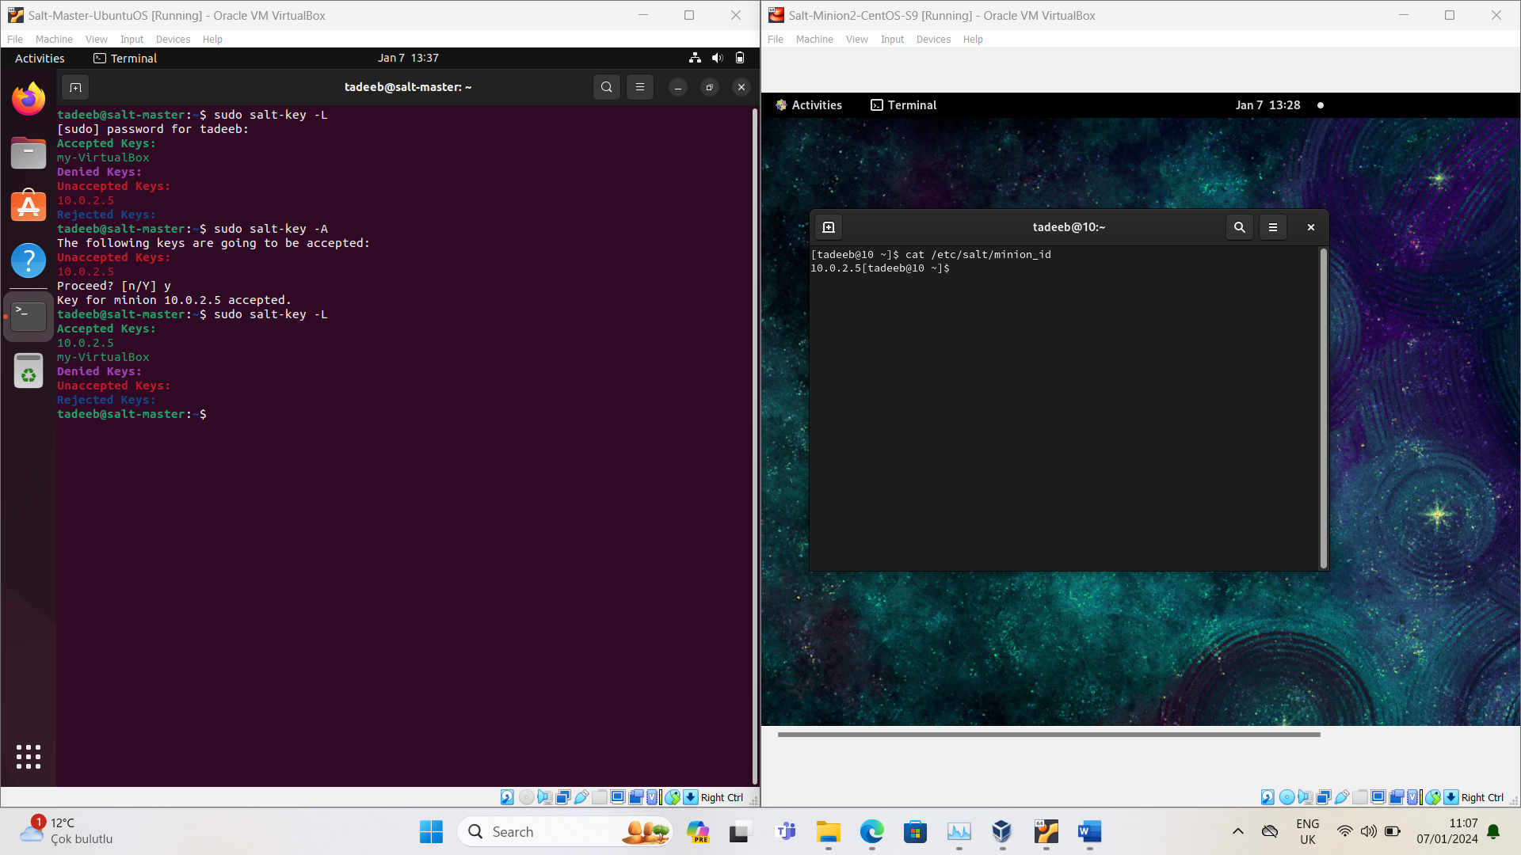



I changed the keys for my convenience:

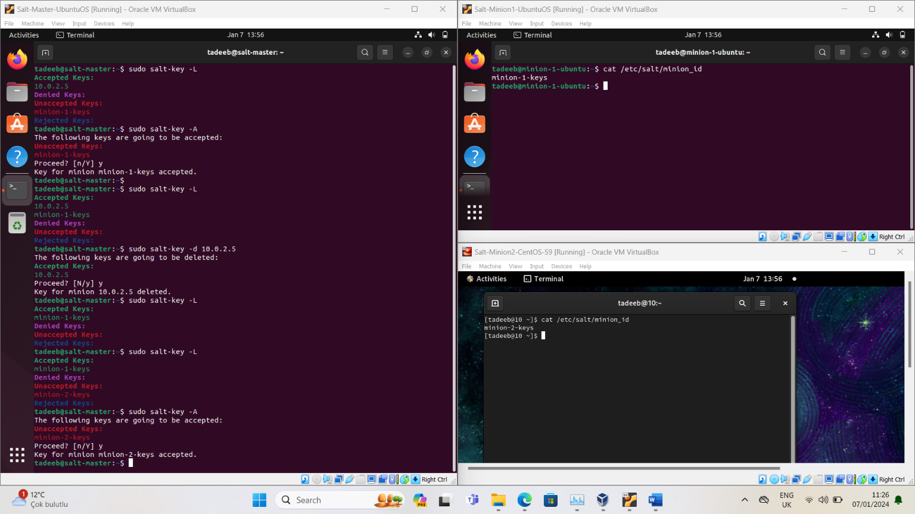

**Step8) Checking whether our Minions are connected with master or not:**

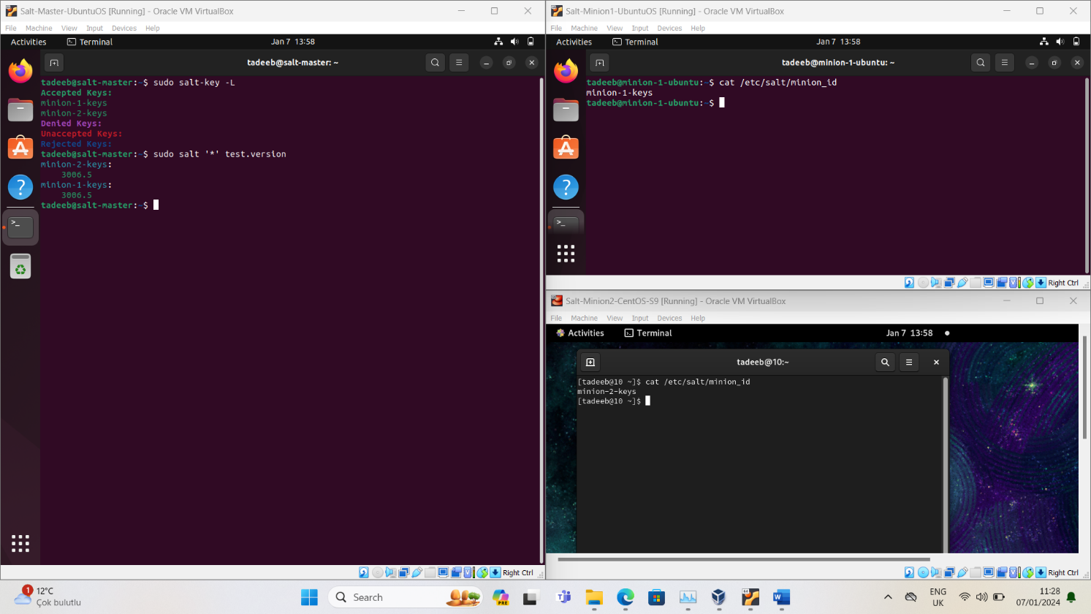

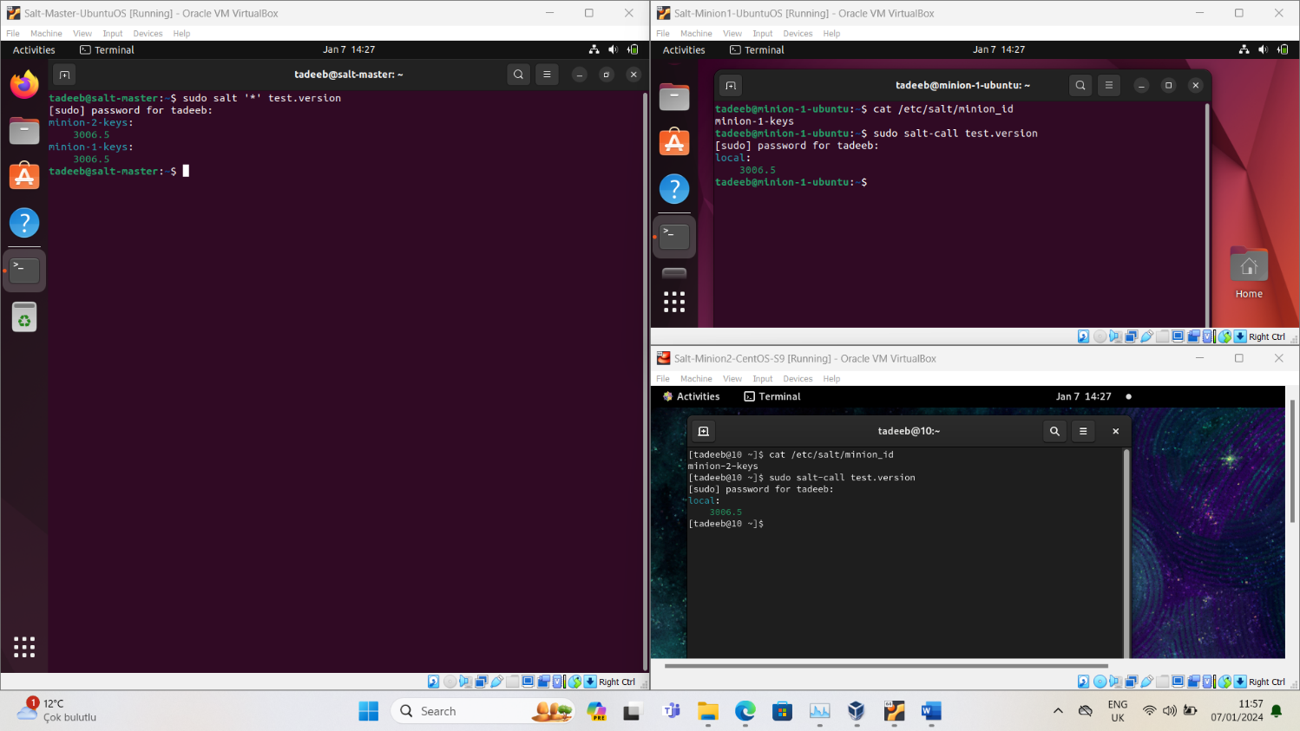Cross confirm from minions:

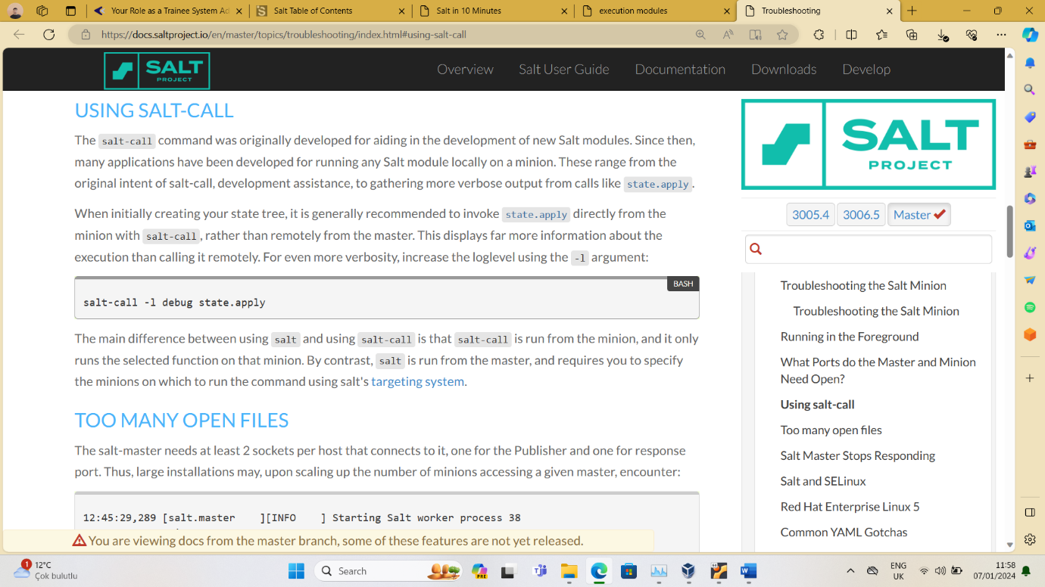

**Step9)** Performing the given task:

# 

Directory Structure:

**On both servers:**

* Create a user named kartaca with user and group ID 2023, home directory, default shell, password carthage2023. (Keep the user password information on the pillar data, not the state file.)/home/krt/bin/bash

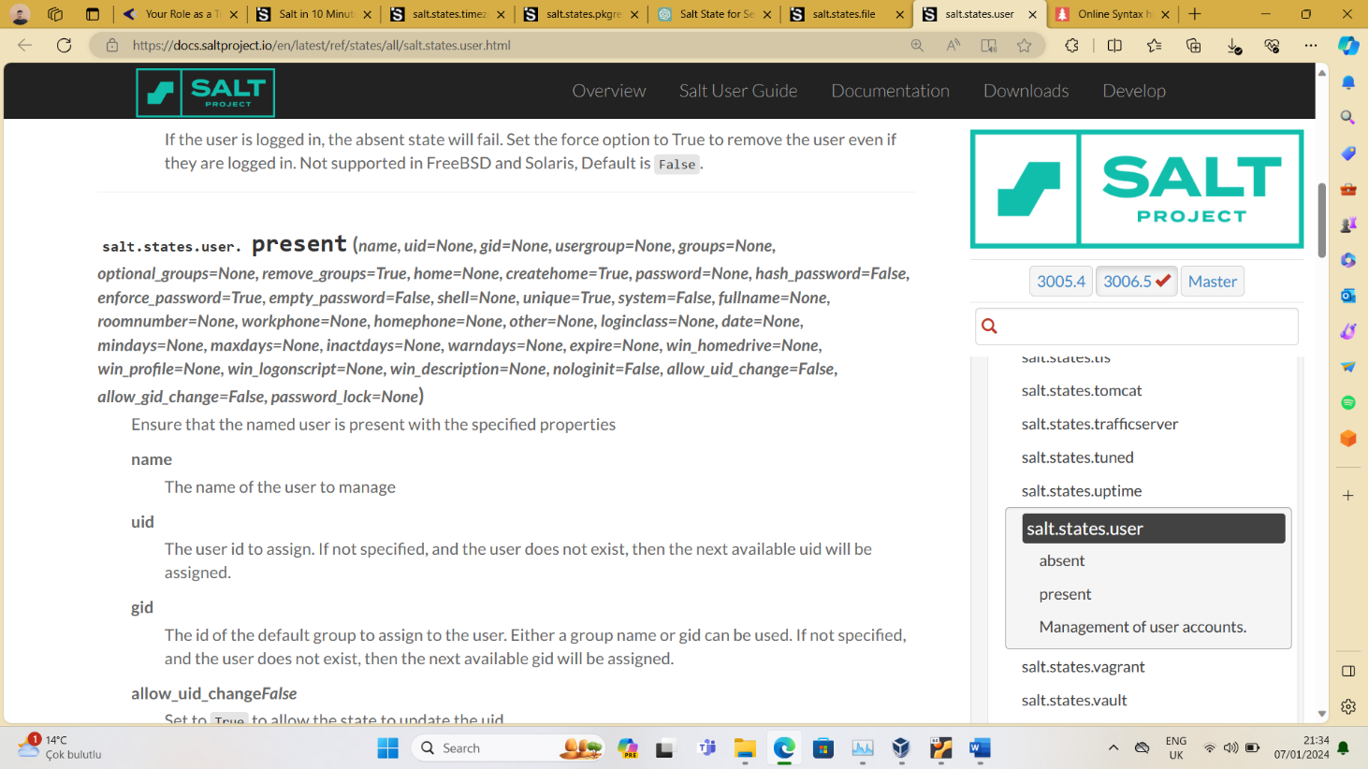

* Give sudo privileges to the Carthage user and this user can run his command on Ubuntu and his command on Centos without entering a password.sudo aptsudo yum

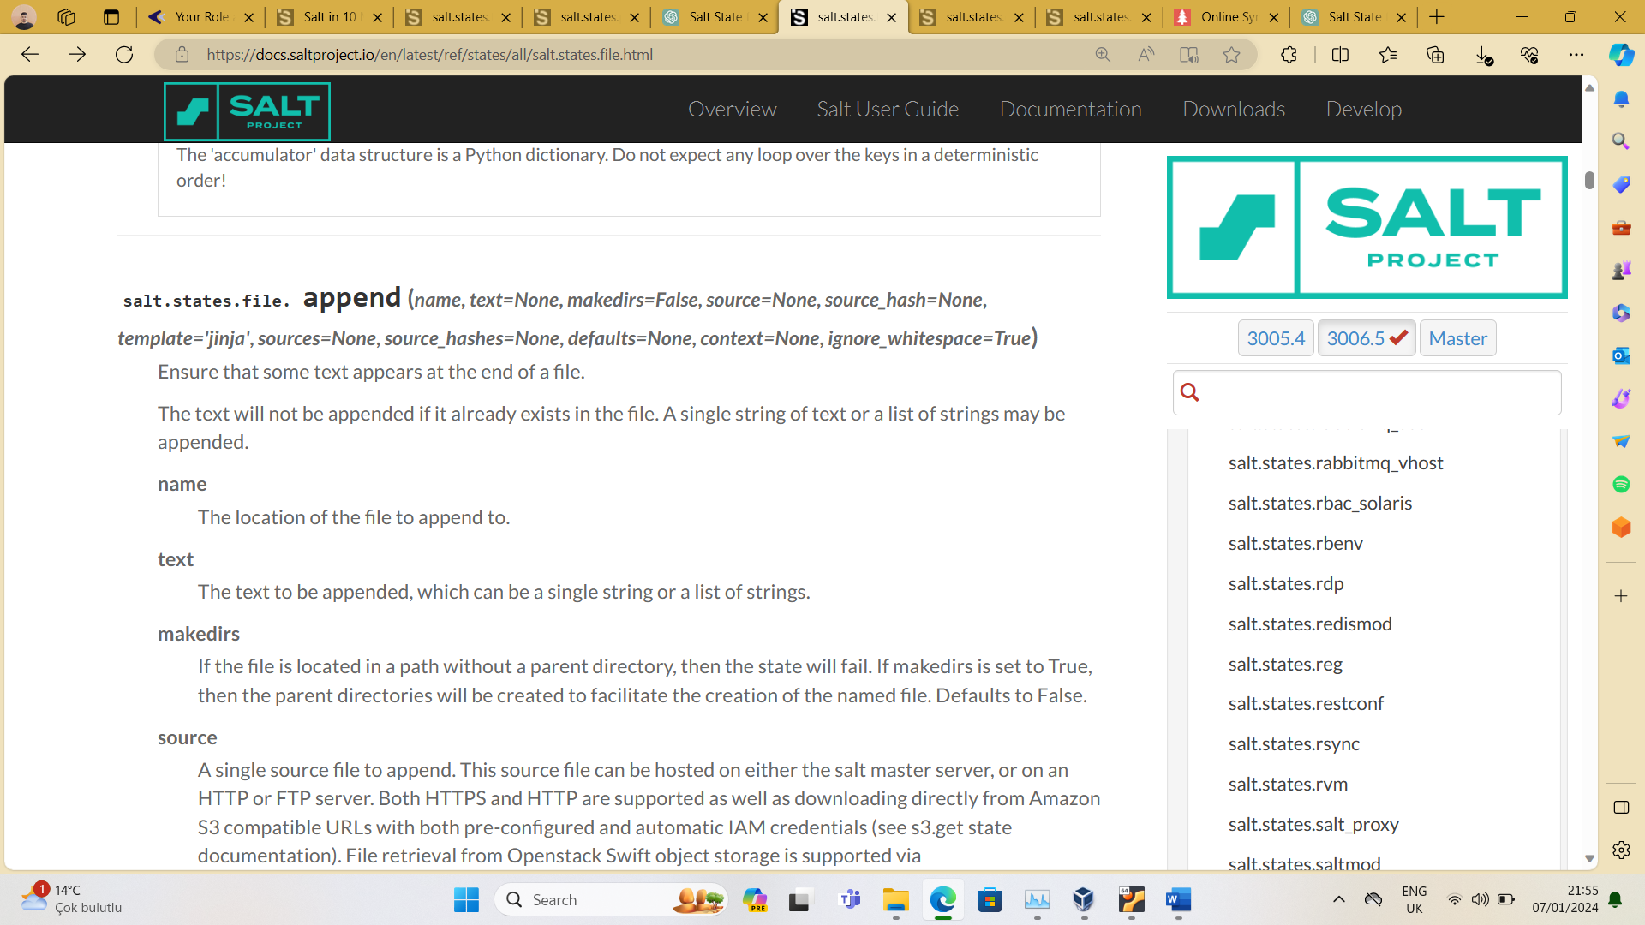

* Set the server timezone to Istanbul.

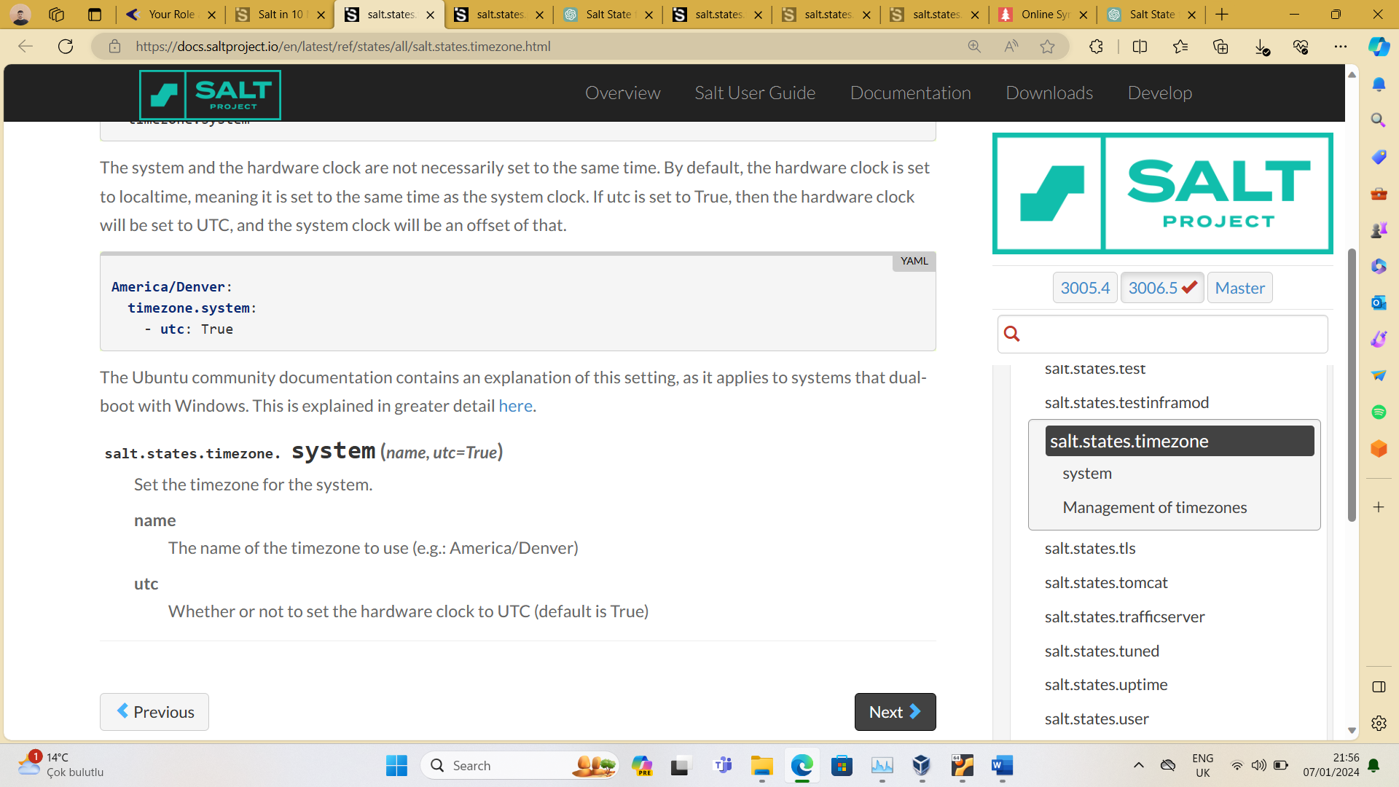

* Enable IP Forwarding permanently.

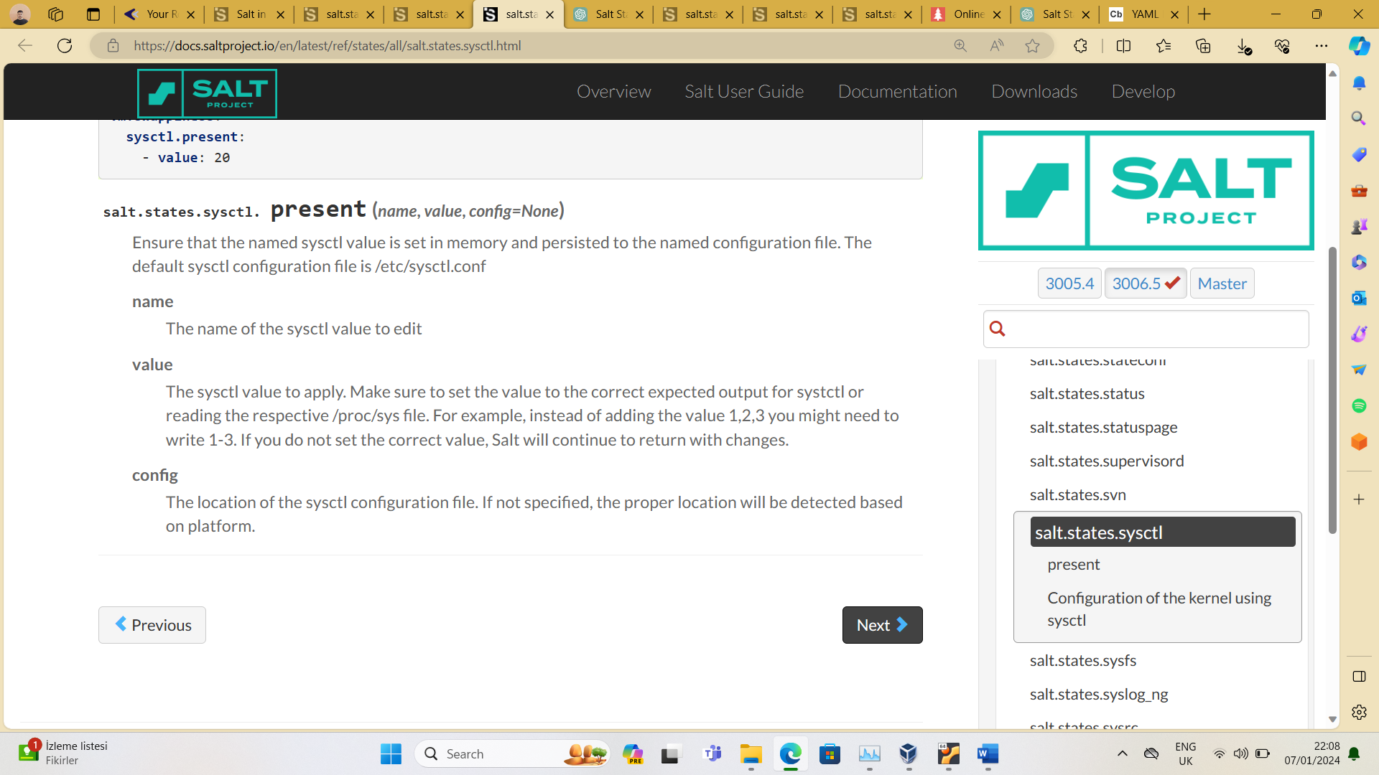

* Install the necessary packages to be able to run the , commands from the terminal.htop tcp traceroute ping dig iostat mtr

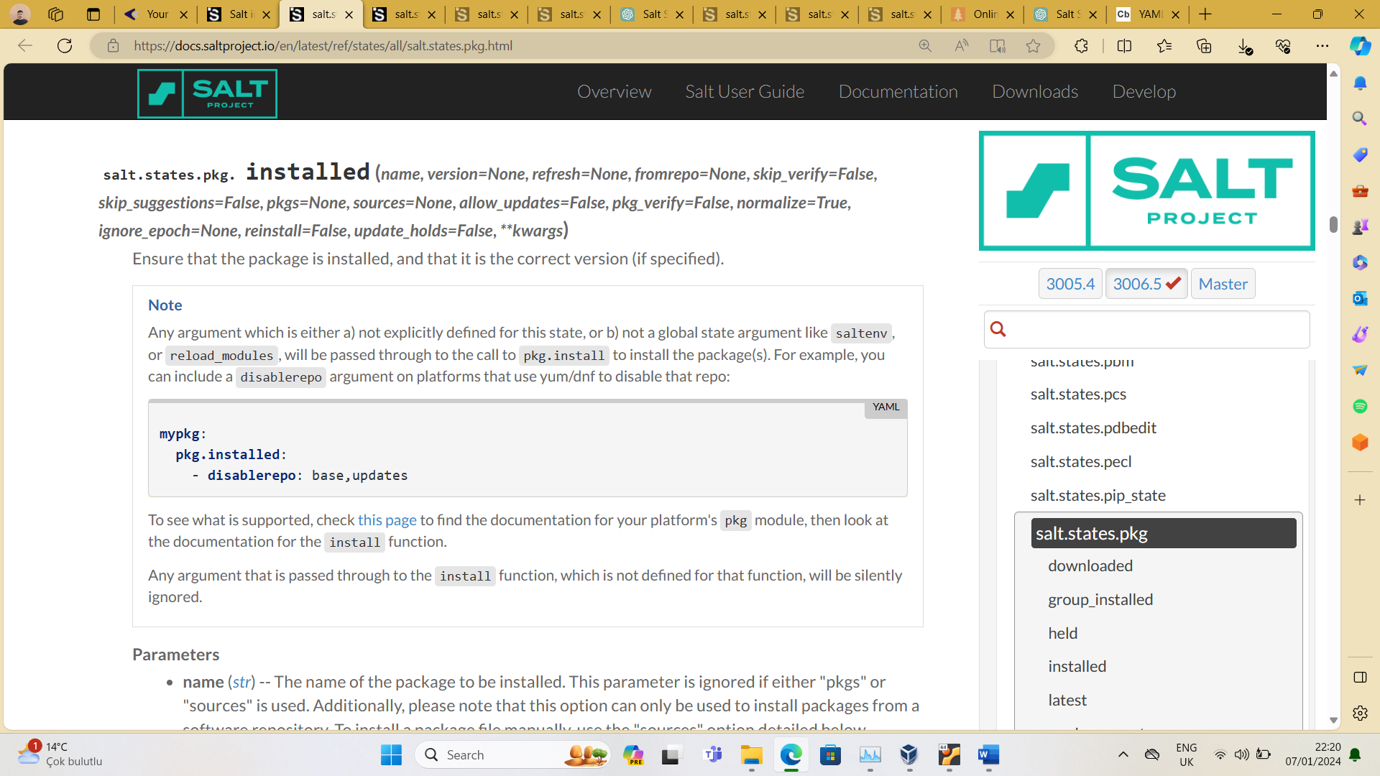

* [Add](https://www.hashicorp.com/official-packaging-guide) the Hashicorp repo to the system with the information at https://www.hashicorp.com/official-packaging-guide and install the v1.6.4 version of the Terraform package.

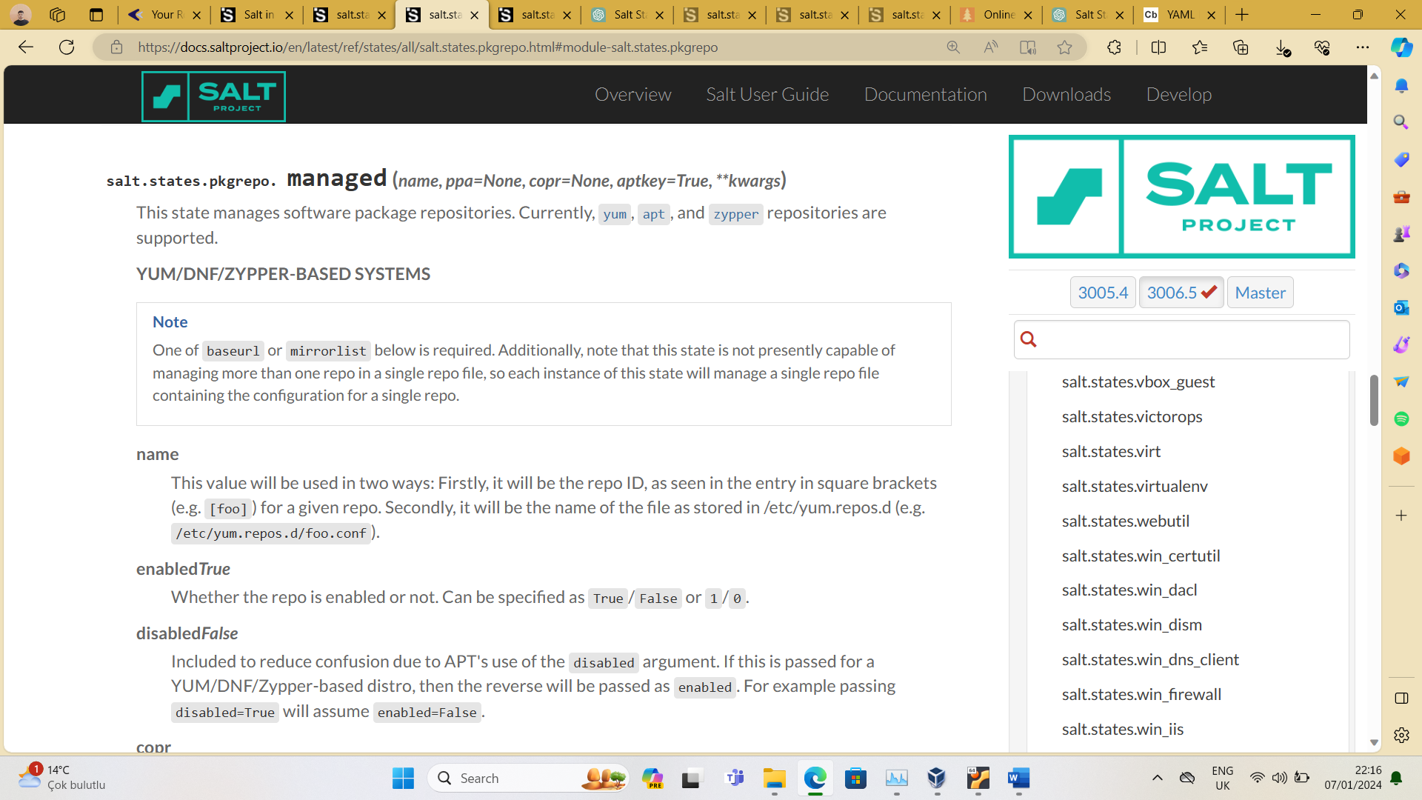

* For each IP address in the 192.168.168.128/28 IP block, add the host record to the file to resolve the kartaca.local address. Make this change with the for loop in the Salt state file./etc/hosts

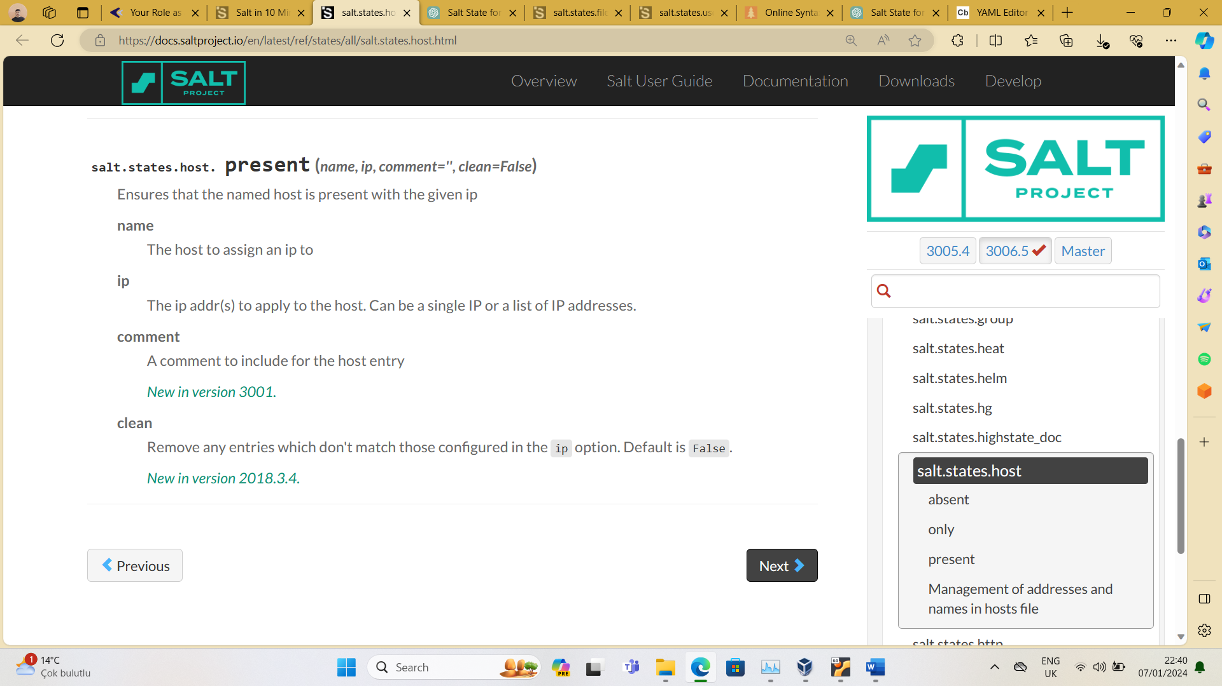

**Step10)**

**On the Centos server:**

* Install Nginx web server.
* Configure the Nginx service to start automatically every time the server restarts.

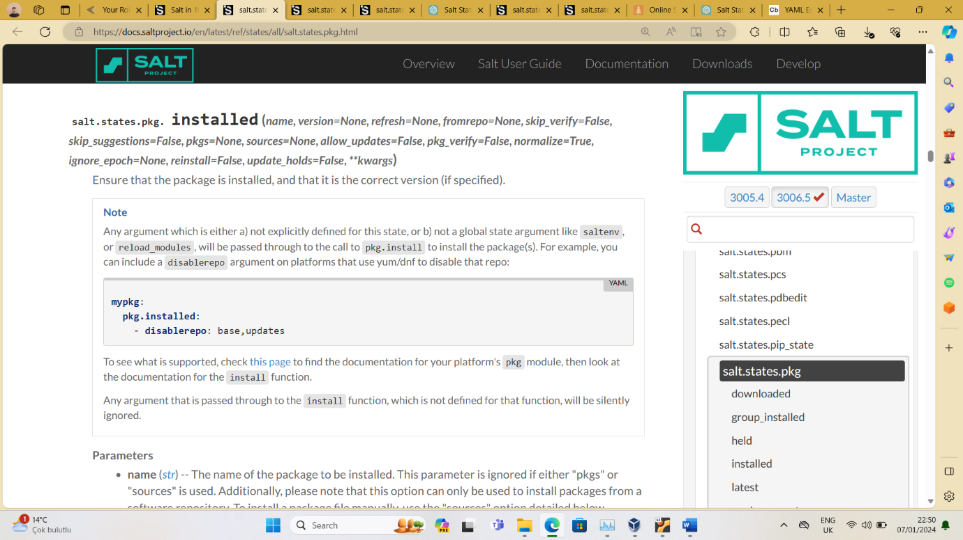

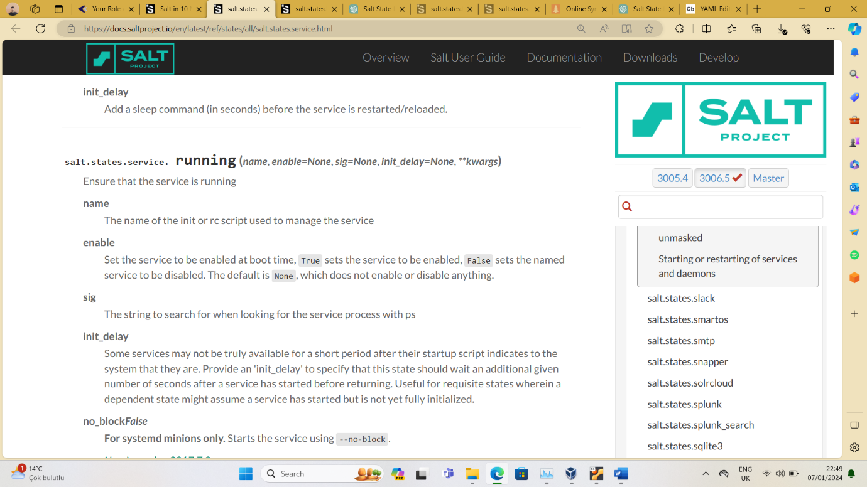

* Install the necessary PHP packages to run WordPress on the server, make the necessary Nginx/PHP configurations.



* [Download](https://wordpress.org/download) the WordPress archive file from https://wordpress.org/download to its directory./tmp

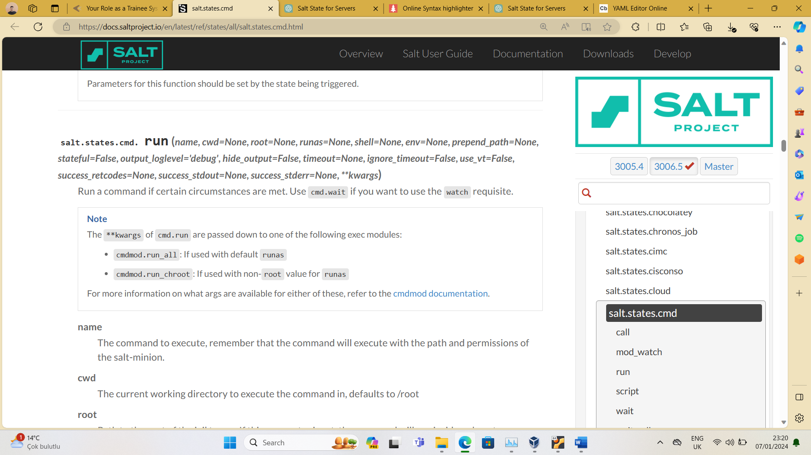

* Unzip the WordPress archive file to its directory./var/www/wordpress2023



* Configure the Nginx service to reload each time the contents of the /etc/nginx/nginx.conf file are updated.



* wp-config.php Enter the MySQL database and user information you created on the Ubuntu server in the database information in the file.
* wp-config.php Fill in the file by pulling the necessary secrets and keys for WordPress from [the https://api.wordpress.org/secret-key/1.1/salt/](https://api.wordpress.org/secret-key/1.1/salt/) address.



{{ pillar['mysql']['db_name'] }} will be replaced with the value of db_name from the pillar file.

{{ pillar['mysql']['db_user'] }} will be replaced with the value of db_user from the pillar file.

{{ pillar['mysql']['db_password'] }} will be replaced with the value of db_password from the pillar file.

In the sed command, database_name_here, username_here, and password_here are just placeholders. They need to match the placeholders used in your wp-config.php file that you want to replace

The /g at the end of the substitution expression stands for "global." It tells sed to replace all occurrences of the pattern in each line, not just the first occurrence.

* Create a self-signed SSL certificate and include it in the Nginx configuration.



* Manage the Nginx configuration with Salt, each time Salt state is applied, the file on the server is updated from the file in the files directory, which is in the same directory as the Salt state file./etc/nginx/nginx.confnginx.conf

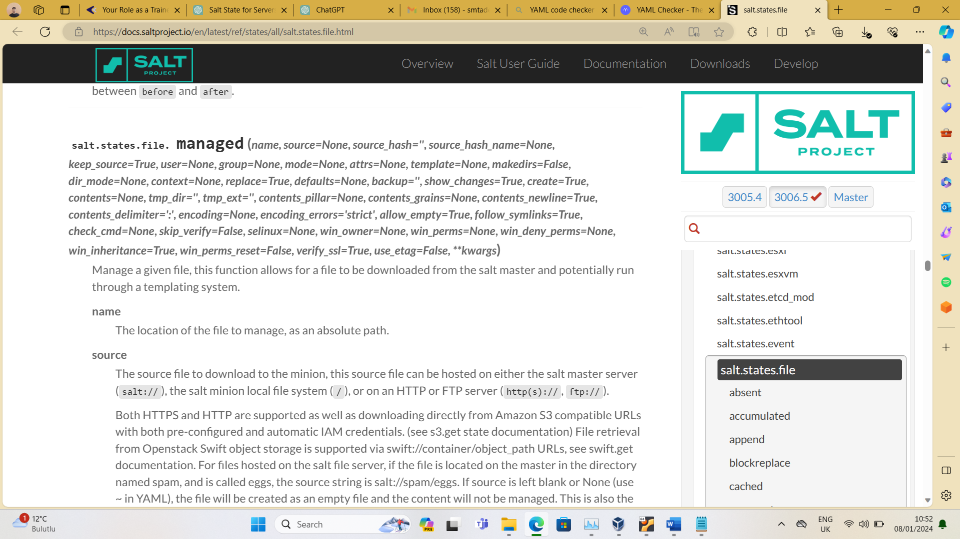

I added this file at /srv/salt/files/nginx.conf:

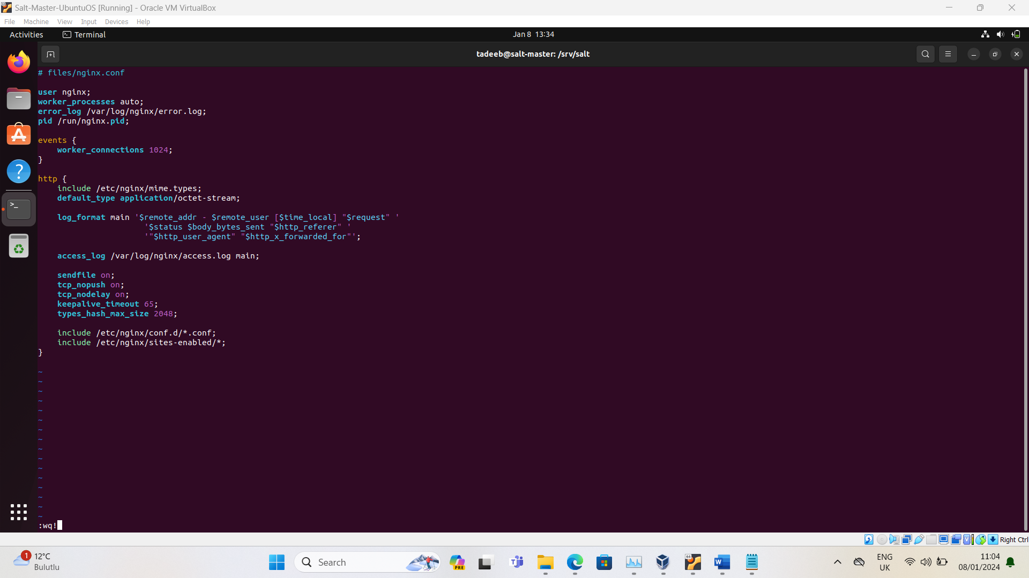

* Create a cron that will stop and restart the Nginx service on the first day of each month.

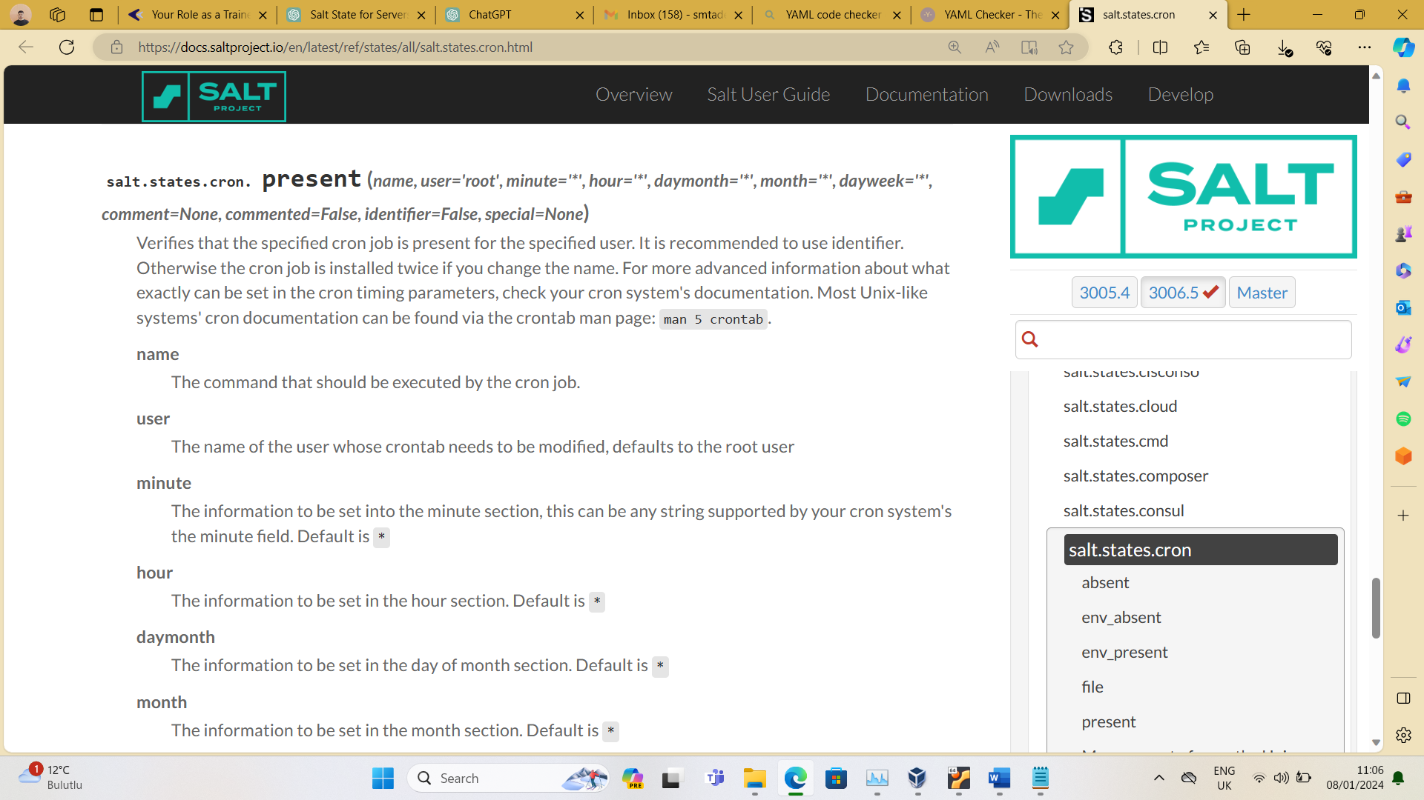

* Make a logroate configuration that will rotate nginx logs hourly, compress rotated log files with gzip, and store only the last 10 files.



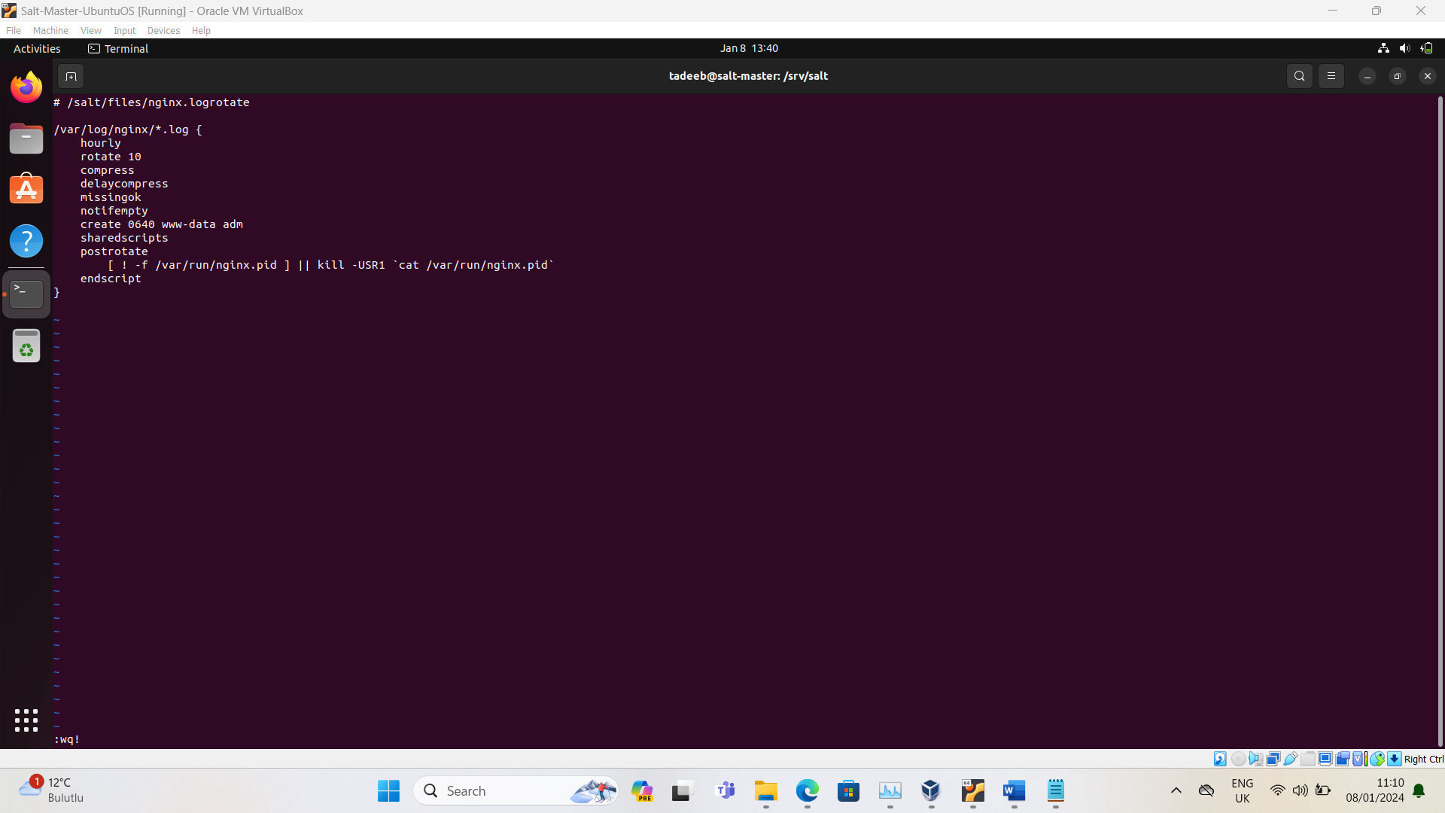

**On the Ubuntu server:**

* Set up a MySQL database.



* Configure the MySQL service to start automatically when the server restarts.



* Create a database and user on MySQL for WordPress installation, define the necessary database privileges for the user you created. (Get the required information for the database name, user, and password from the pillar data, not from the Salt state file.)

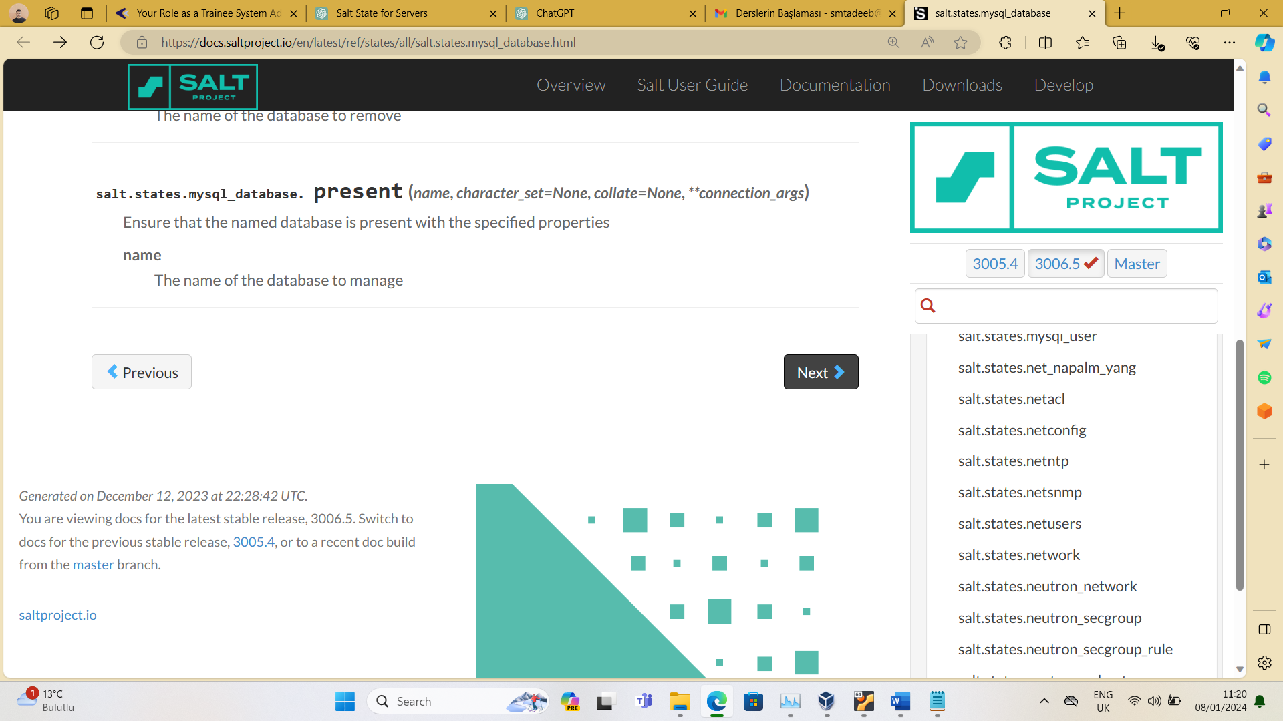

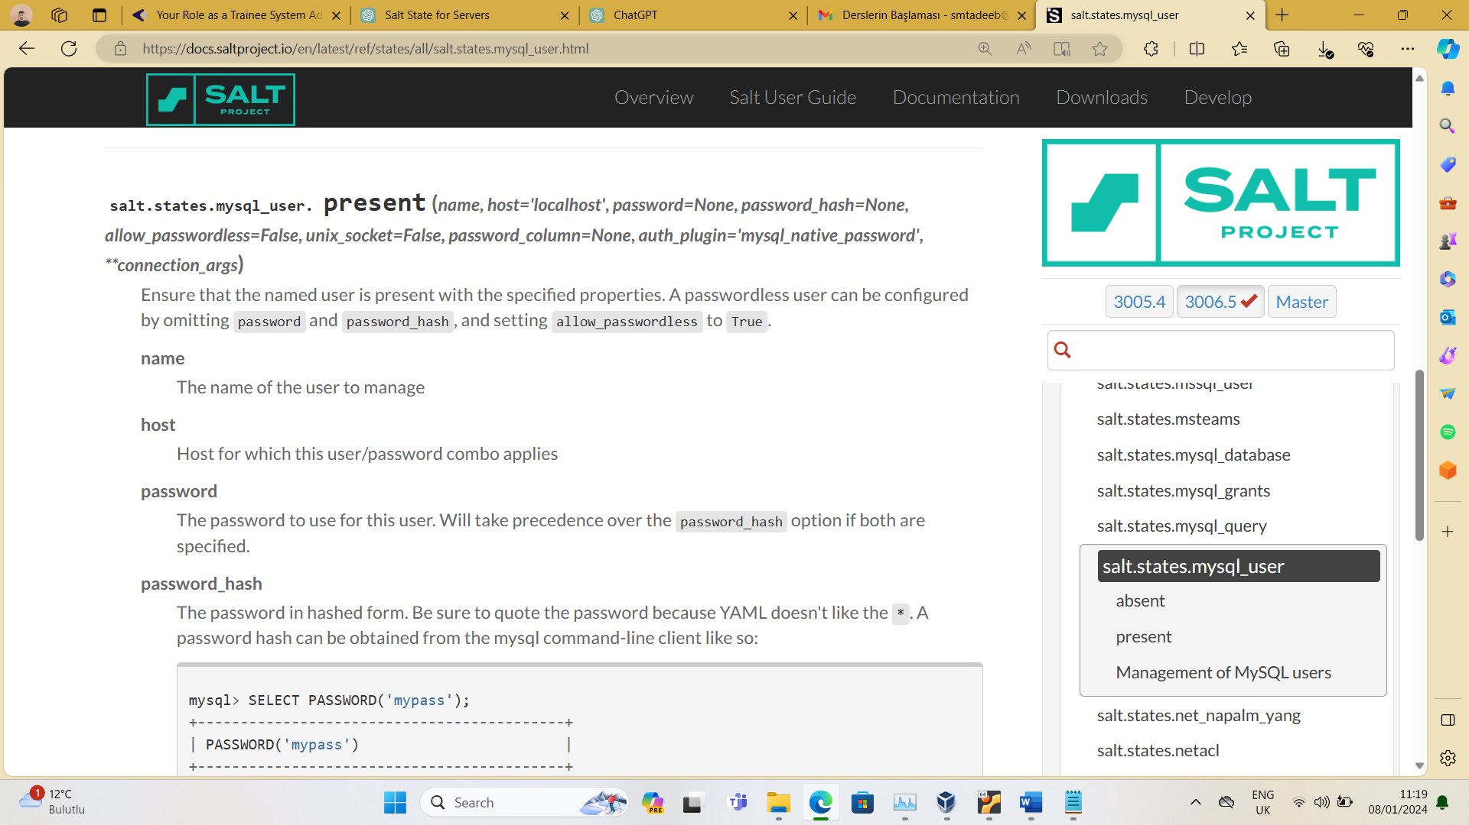

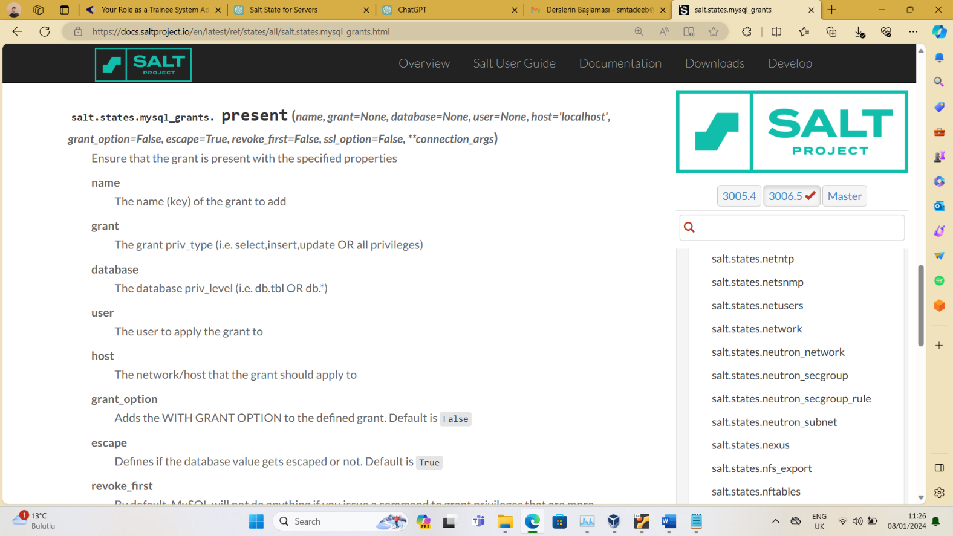

* Prepare a cron that will index the MySQL database dump every night at 02:00. /backup

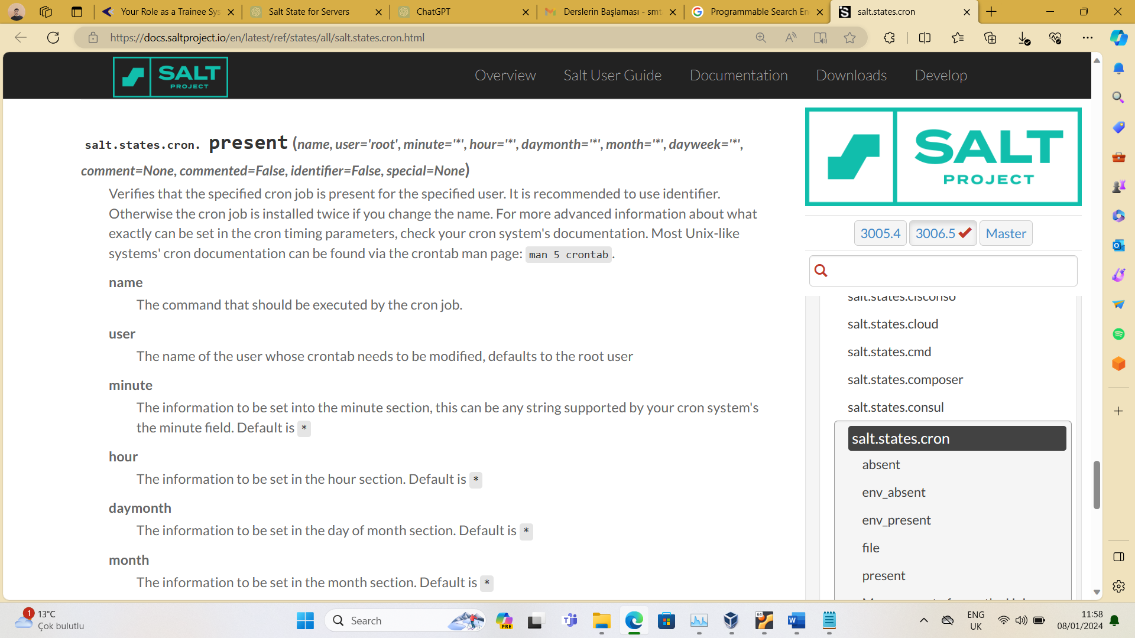

* **Testing:**

NOTE : The whole code file is uploaded on my github.

I did testing and 80% of my code is working, rest 20% is issue in last part i.e. MySql modules.